ON
THE
NATURE
OF
THINGS
Part I

The Book Of The Theory

Theory One: Time, Space, Matter

Before we begin, let’s first understand orders of magnitude. Take one million marbles, as an example. We have a unit of measurement, the number of marbles. I could write this as “1,000,000 marbles”, or as “1 * 10^6 marbles”, or even as “one million marbles”. If I define this as a mega-marble it means that I have now simplified this setup, by introducing a new unit of measurement. Since numbers can get very huge very fast, it becomes useful to define a new system of prefixes for our numbers. We have already met one prefix, mega, which means million. There are others too. A marble is 1 marble. A kilo-marble is 1,000 marbles. A mega-marble is 1,000 kilo-marbles. A giga-marble is 1,000 mega-marbles. A tera-marble is 1,000 giga-marbles. A peta-marble is 1,000 tera-marbles. This pattern continues on, by multiplying by one thousand every time. If we divided by a thousand instead of multiplying, we arrive at the following units of, milli-marbles, micro-marbles, nano-marbles, pico-marbles, and femto-marbles.
Now with this in mind, imagine two marbles floating in the void. Both marbles each maintain their motion, as they both independently travel in straight lines with a constant speed. Time runs at the same universal rate for both marbles. The two marbles both have definite positions as well as definite velocities. This all makes perfect sense. In order to define what is going on, we introduce a system of units that measure space, time, and matter.
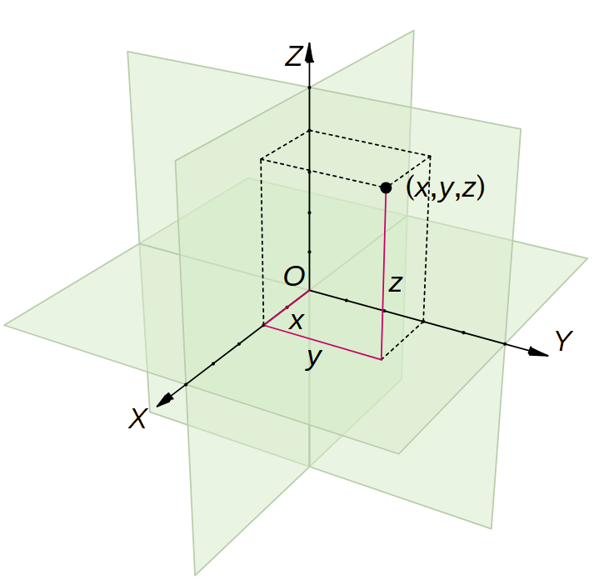
Space is measured by using a three dimensional coordinate grid. The X dimension runs from left to right. Next, the Y dimension goes from the back to the front. Lastly, the Z dimension points straight up. By measuring these three numbers, we can find the position of any marble. This is just like the addresses in a city, which uses the street numbers, avenue numbers, and floor numbers. We thus define the meter as our unit of distance in space.
The Meter is defined as follows: Walking in a straight line from the equator to the north pole is by definition 10 million meters. One centimeter is 0.01 meters. An inch is 2.54 centimeters. A foot is 12 inches. A yard is 3 feet. A mile is 1,760 yards. Similarly, a kilometer is one thousand meters, and a millimeter is a thousandth of a meter.
The amount of matter in a marble measures its resistance to a change in its motion. Marbles like everything else are made of fundamental indivisible particles, called atoms. These atoms behave just like tiny identical marbles, since they too, like everything else, maintain their state of motion. This means that the amount of matter in a marble maintaining its motion, is then just the total number of atoms in that marble, which are all maintaining their motions. Similarly for two or more marbles, the total amount of matter is just the total number of atoms in all of our marbles. We call the amount of matter inherited to an object, as its mass, and is measured in grams.
The Gram is defined as follows: By definition, a cubic centimeter of water has a mass of a gram. One ounce is 28.349523125 grams. A pound is 16 ounces. A ton is 2 thousand pounds. Similarly, a kilogram is one thousand grams, and a milligram is a thousandth of a gram.
Time controls the evolution of the marbles. This is because, since the marbles are moving, their positions change over time. At every moment or snapshot of time, there is a unique configuration of our marbles. To specify which configuration we are talking about, it becomes useful to introduce a clock that measures which snapshot we are in. Playing each snapshot back in sequence, moment after moment, we recover the evolution of the scene. This is just like the pages in a flip book or the frames of film in a movie projector. The clock time is universal and we count the frames with a new unit of measurement, the second.
The Second is defined as follows: A full day by definition lasts 86,400 seconds. A minute is 60 seconds. An hour is 60 minutes. A day is then 24 hours. One week is 7 days. One month is 4 and 1/3 weeks. A year is 12 months. A decade is 10 years. A generation is 3 decades. Similarly, a kilosecond is one thousand seconds, and a millisecond is a thousandth of a second.
As it turns out, it doesn’t matter what units of measurement we use to describe the marbles, the result is always the same. As an example, we could define a totally new system of units with miles, pounds, and hours, instead of meters, grams, and seconds. Even though the numbers will be different, the physics of our two marbles will be exactly identical. This is true, even in different setups. We can therefore get rid of our units of measurement, and claim that the physics of the marbles will work regardless. With the physics of our two marbles, it seems like our lives are also a linear mechanical progression, because like the marbles, we too are made of atoms. We then conclude that our clockwork universe is made up of atoms meaninglessly drifting in the void, and is completely deterministic. This is sadly just the way it is. Or is it?

Mathematical Details:

A 30 bit to 200 bit ratio units of measurement in the Toy Scale Universe:
t = 1 r = 1 m = 1
t = 32 r = 32 m = 0.03125
t = 32 r = 32 m = 32
t = 32 r = 8 m = 0.5
t = 1,024 r = 1,024 m = 0.0009765625
t = 1,024 r = 1,024 m = 1
t = 1,024 r = 1,024 m = 1,024
t = 1,024 r = 256 m = 0.015625
t = 1,024 r = 256 m = 16
t = 1,024 r = 64 m = 0.25
t = 32,768 r = 32,768 m = 0.000030517578125
t = 32,768 r = 32,768 m = 0.03125
t = 32,768 r = 32,768 m = 32
t = 32,768 r = 32,768 m = 32,768
t = 32,768 r = 8,192 m = 0.00048828125
t = 32,768 r = 8,192 m = 0.5
t = 32,768 r = 8,192 m = 512
t = 32768 r = 2,048 m = 0.0078125
t = 32,768 r = 2,048 m = 8
t = 32,768 r = 512 m = 0.125
t = 1,048,576 r = 1,048,576 m = 0.00000095367431640625
t = 1,048,576 r = 1,048,576 m = 0.0009765625
t = 1,048,576 r = 1,048,576 m = 1
t = 1,048,576 r = 1,048,576 m = 1,024
t = 1,048,576 r = 1,048,576 m = 1,048,576
t = 1,048,576 r = 262,144 m = 0.0000152587890625
t = 1,048,576 r = 262,144 m = 0.015625
t = 1,048,576 r = 262,144 m = 16
t = 1,048,576 r = 262,144 m = 16,384
t = 1,048,576 r = 65,536 m = 0.000244140625
t = 1,048,576 r = 65,536 m = 0.25
t = 1,048,576 r = 65,536 m = 256
t = 1,048,576 r = 16,384 m = 0.00390625
t = 1,048,576 r = 16,384 m = 4
t = 1,048,576 r = 4,096 m = 0.0625
t = 33,554,432 r = 33,554,432 m = 0.0000000298023223876953125
t = 33,554,432 r = 33,554,432 m = 0.000030517578125
t = 33,554,432 r = 33,554,432 m = 0.03125
t = 33,554,432 r = 33,554,432 m = 32
t = 33,554,432 r = 33,554,432 m = 32,768
t = 33,554,432 r = 33,554,432 m = 33,554,432
t = 33,554,432 r = 8,388,608 m = 0.000000476837158203125
t = 33,554,432 r = 8,388,608 m = 0.00048828125
t = 33,554,432 r = 8,388,608 m = 0.5
t = 33,554,432 r = 8,388,608 m = 512
t = 33,554,432 r = 8,388,608 m = 524,288
t = 33,554,432 r = 2,097,152 m = 0.00000762939453125
t = 33,554,432 r = 2,097,152 m = 0.0078125
t = 33,554,432 r = 2,097,152 m = 8
t = 33,554,432 r = 2,097,152 m = 8,192
t = 33,554,432 r = 524,288 m = 0.0001220703125
t = 33,554,432 r = 524,288 m = 0.125
t = 33,554,432 r = 524,288 m = 128
t = 33,554,432 r = 131,072 m = 0.001953125
t = 33,554,432 r = 131,072 m = 2
t = 33,554,432 r = 32,768 m = 0.03125
t = 1,073,741,824 r = 1,073,741,824 m = 0.000000000931322574615478515625
t = 1,073,741,824 r = 1,073,741,824 m = 0.00000095367431640625
t = 1,073,741,824 r = 1,073,741,824 m = 0.0009765625
t = 1,073,741,824 r = 1,073,741,824 m = 1
t = 1,073,741,824 r = 1,073,741,824 m = 1,024
t = 1,073,741,824 r = 1,073,741,824 m = 1,048,576
t = 1,073,741,824 r = 1,073,741,824 m = 1,073,741,824
t = 1,073,741,824 r = 268,435,456 m = 0.00000001490116119384765625
t = 1,073,741,824 r = 268,435,456 m = 0.0000152587890625
t = 1,073,741,824 r = 268,435,456 m = 0.015625
t = 1,073,741,824 r = 268,435,456 m = 16
t = 1,073,741,824 r = 268,435,456 m = 16,384
t = 1,073,741,824 r = 268,435,456 m = 16,777,216
t = 1,073,741,824 r = 67,108,864 m = 0.0000002384185791015625
t = 1,073,741,824 r = 67,108,864 m = 0.000244140625
t = 1,073,741,824 r = 67,108,864 m = 0.25
t = 1,073,741,824 r = 67,108,864 m = 256
t = 1,073,741,824 r = 67,108,864 m = 262,144
t = 1,073,741,824 r = 16,777,216 m = 0.000003814697265625
t = 1,073,741,824 r = 16,777,216 m = 0.00390625
t = 1,073,741,824 r = 16,777,216 m = 4
t = 1,073,741,824 r = 16,777,216 m = 4,096
t = 1,073,741,824 r = 4,194,304 m = 0.00006103515625
t = 1,073,741,824 r = 4,194,304 m = 0.0625
t = 1,073,741,824 r = 4,194,304 m = 64
t = 1,073,741,824 r = 1,048,576 m = 0.0009765625
t = 1,073,741,824 r = 1,048,576 m = 1
t = 1,073,741,824 r = 262,144 m = 0.015625

Practice Questions:
1a). Study the units of measurement and make a scale model of the universe by changing the orders of magnitude of space, time, and matter, both independently, and then vary all three scales simultainiously.

Theory Two: Relativistic Quantum Gravity and CGH Physics

This was the physics of the industrial revolution, written in 1687 by the greatest scientist who ever lived. Isaac Newton. However, by the turn of the 20th century, experiments began to show that Newtonian mechanics is not always right, and had to be modified to agree with these radically new groundbreaking experiments. There are three main sets of new phenomena, that were incorporated into the three pillars of modern science. The three pillars are universal gravitation, special relativity, and quantum mechanics. The fate of humanity rests on the unification of physical law.
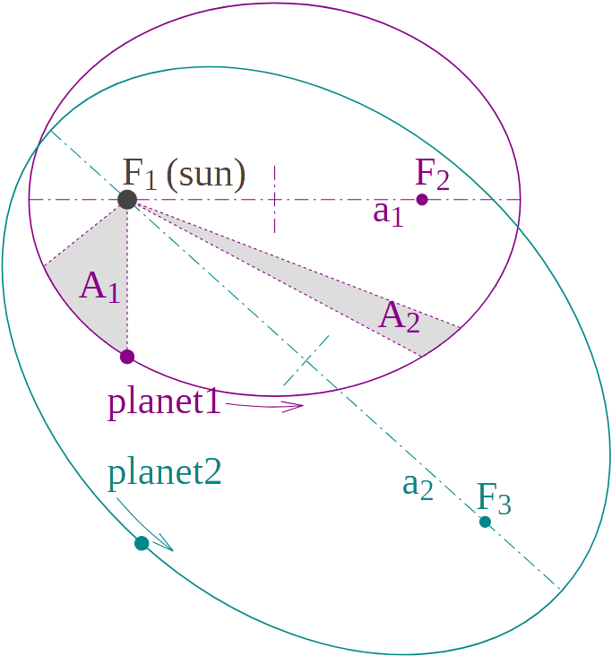
G). Universal Gravitation: All particles attract all other particles, with an inverse square force field, in three dimensional space. This is why all objects fall to the ground at the same rate, why the planets move around the sun in ellipses with the sun at one focus and the other focus empty, and why a line drawn from the sun to a planet sweeps out equal areas in equal time intervals, and also explains why the semi major axis of a planet’s orbit cubed is proportional to the orbital period squared, along with many other gravitational effects. It is the gravitational acceleration of space itself, sourced by a particle, that spreads out according to an inverse square law in 3D space. This is what keeps your feet on the ground, and the earth orbiting the sun.
In the theory of Universal Gravitation, there is a Universal Constant. The constant of Gravity has the value of 6.67408 / 10^14 m^3/g/s^2, in our system of units. This means that the strength of gravity is very weak. To get an idea on how weak gravity is, imagine two cars in deep space, each weighing a ton, parked right next to one another a yard apart. It will still take many hours for the two cars to stick together. Therefore, we can continue to say that, both marbles each maintain their motion, as they both independently travel in straight lines with a constant speed. Despite the fact that these gravitational effects can be ignored in the everyday regime, we still live in a universe dictated by the physics of: universal gravitation. The fact that universal gravitation works at all, shows us just how weird our universe really is. Universal Gravitation was discovered by Newton himself while trying to unify the motion of heaven and earth, and was published in his book, called the Mathematical Principles of Natural Philosophy.
C). Special Relativity: The dimensions of space and time, arrange themselves such that the speed of light is the same, from all moving perspectives. This means that among many new phenomena, fast moving clocks run slow, fast moving rulers contract along their direction of motion, high speed motion breaks the simultaneous nature of time, and most importantly nothing moves faster than the speed of light. The fact that the speed of light moves at the same fixed speed no matter how its source is moving, means that the dimension of time rotates in an opposite way, than the three other dimensions of space rotate.
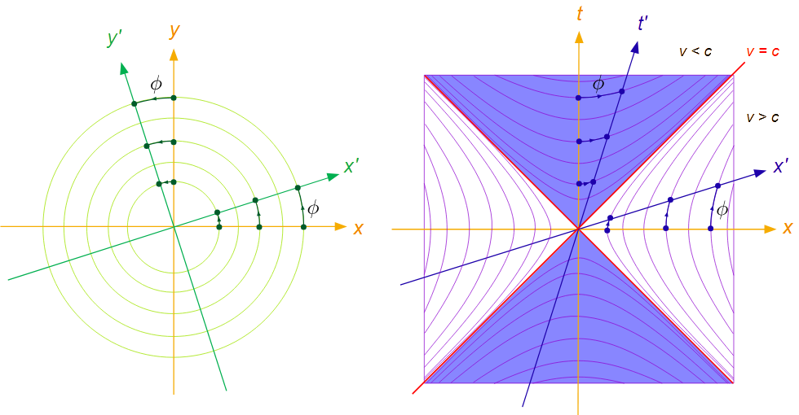
In the theory of Special Relativity, there is a Universal Constant. The constant of Relativity has a value of 2.99792458 * 10^8 m/s, in our system of units. We recognize this as the speed of light. This means that the speed of light is very fast. To get an idea on how fast this is, imagine a foot long segment of fiber optic cable. The latency of your internet connection would be a nanosecond. A nanosecond is a billionth of a second. Therefore, we can continue to say that, time runs at the same universal rate for both marbles. Despite the fact that these relativistic effects can be ignored in the everyday regime, we still live in a universe dictated by the physics of: special relativity. The fact that special relativity works at all, shows us just how weird our universe really is. Special Relativity was put together by Albert Einstein in 1905, in order to describe the strange behavior of the speed of light, along with four other papers that shake physics down to its foundations.
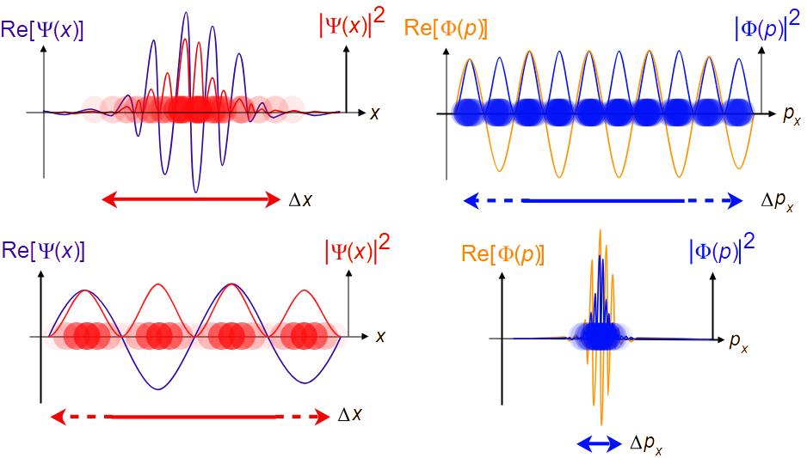
H). Quantum Mechanics: Every wave can be thought of as a stream of particles. The total kinetic energy of such a particle is directly proportional to its corresponding probability wave frequency. Moreover, waves with shorter wavelengths correspond to identical particles with more momentum, that is to say, the product of mass and velocity. This leads to the notion that objects can be in more than two places at once, how particles and waves are actually the same thing, how these quantum waves have discrete harmonics like the specific notes on a musical intrument, and the weird notion that measuring one particle can reveal corelations in the properties of all other particles of the same type.
In the theory of Quantum Mechanics, there is a Universal Constant. The constant of Quantum has a value of 6.62607015 / 10^31 m^2*g/s, in our system of units. This means that the amount of quantum uncertainty is very certain. To get an idea of how certain quantum physics is, imagine a grain of dust, weighing less than a microgram, sitting on your desk at school. After 30 years, your kid, now sitting at your desk at school, notices that the same exact dust grain has moved by a millionth of an inch. Therefore, we can continue to say that, the two marbles both have definite positions as well as definite velocities. Despite the fact that these quantum effects can be ignored in the everyday regime, we still live in a universe dictated by the physics of: quantum mechanics. The fact that quantum mechanics works at all, shows us just how weird our universe really is. Quantum Mechanics was constructed by a band of nuclear physicists in order to explain the rainbow of a fluorescent light source.
To conclude, each of these pillars of physics, has radically altered our understanding of our two marbles. Our common sense vision of life as a mechanical linear progression, is just all wrong. Every pillar of physics, introduces a new universal constant. The associated physics reduces to our common sense, by making a series of approximations. So even though our common sense worldview works well in the everyday, in the grand scheme of things, our universe is stranger than fiction.

The Mathematical Details:
1). Galilean transformed particle

C). Lorentz transformed particle

G). Kepler orbit problem

CG). Schwarzschild metric geodesics

H). Shrodinger equation

CH). Klein Gordon equation

GH). Hydrogen atom wavefunctions

CGH). Klein Gordon equation in the Schwarzschild metric

Practice Questions:
2a). Show that the CGH equation reduces to equation 1 in the limits where C,G,H physics becomes unnecessary.
2b). Run a simulation of all 8 equations, and find analytical solutions for each equation.
2c). Draw out a CGH physics cube, with the 8 simulation results posted on all 8 vertices of the cube. Make sure that the three axes coorespond to C,G,H, physics accordingly, and analyze the units of measurement in each case.

Theory Three: Rotating Black Holes and Discrete Field Quanta

At this point, we have all of the pillars of physics we need, in order to unify all of physics into the theory of everything. However, such a unification of physics will require two radical paradigm shifts. The first idea is all about special relativity, and how to unify it with the rest of physics. The second idea is to reconsider the properties of matter, such as mass and spin. Lets review some key ideas in special relativity before we move on. The spacetime of special relativity, also known as Minkowski spacetime, replaces the idea of absolute time, with the idea of an absolute light speed. With this idea in mind, the symmetries of space and time, unify into a structure known as spacetime.
To unify special relativity with universal gravitation, imagine two gravitating marbles. Placed at rest an infinite distance apart, the two marbles will gradually begin to accelerate toward one another. The speed needed to break the fall, is known as the escape velocity, and is also the speed at which space itself carries the marbles together. However, we know that gravity spreads out with distance, meaning that the escape velocity would exceed light speed at a close enough distance. In a sense, space itself is falling inwards, faster than light can. And since nothing can propagate faster than light, everything inside this distance is trapped forever. This is the event horizon of a black hole!
Going back to our two marbles, we know that they are actually two black holes. The mass of each black hole, is simply the size of its own event horizon. The year is 1915. Albert Einstein completes his General Theory of Relativity. Weeks later, Carl Schwarzschild found the spacetime geometry around a simple black hole. The Schwarzschild spacetime reduces to special relativity and universal gravitation, in their respective domains. However, black hole orbits do things not seen before in science. Time slows down, light bends, orbits precess around. Closer in, gravity increases like a rip tide, rendering circular orbits unstable. Even closer, and it is possible for light to orbit temporarily. Crazy stuff.
For fun, lets dive into a Schwarzschild black hole. Far away from the hole, its gravity seems normal, since the paths of objects around it, the orbits, behave as we would expect. The slowest orbits are the elliptical orbits, like the earth around the sun for example. Faster orbits, like that of a comet passing by a planet, are known as fly-by orbits. The fastest orbits are the straight lines that light takes to reach your eyes. Closer in, say within a few dozen black hole radii away, the gravity is so powerful that light rays will noticeably bend, just like the flyby orbits we mentioned. On the other hand, the slower elliptical orbits are also acting very strangely. They undergo a phenomenon known as precession, which is to say that the closest point of the orbit, the perihelion, shifts in the same direction of the orbit itself, turning a simple ellipse into a daisy pattern. Then, at three black hole radii from the black hole, circular orbits become unstable. This means that a small push will either send us flying into the hole, or off into deep space. At this distance, orbits zoom and whirl around the hole. The orbital precession and time dilation effects are clearly noticeable. Closer in than three radii from the hole, faster and faster elliptical orbits become unstable, until we arrive at two black hole radii from the black hole, at which flyby orbits start being unstable too. The only orbits possible are the highly bent light rays, which also follow flyby orbits. Then, at a special distance of one and a half radii away from the black hole, light can orbit the black hole. However this orbit is unstable, and the light rays either fly off to infinity, or plunge into the black hole. Even closer than this, and orbits do not exist, since the orbital speed needed would be faster than light. Just above the event horizon, it is still possible to escape the gravity of the black hole. However, as we approach the horizon at one black hole radius, the chance to fly away gets slimmer and slimmer. Time slows to a halt, when seen from the outside. Then as you cross the invisible spherical boundary, you are doomed to hit the central singularity, where everything you know comes to an end. Seen from outside however, nobody even sees you cross the event horizon at all, as your image fades away on the black hole surface.
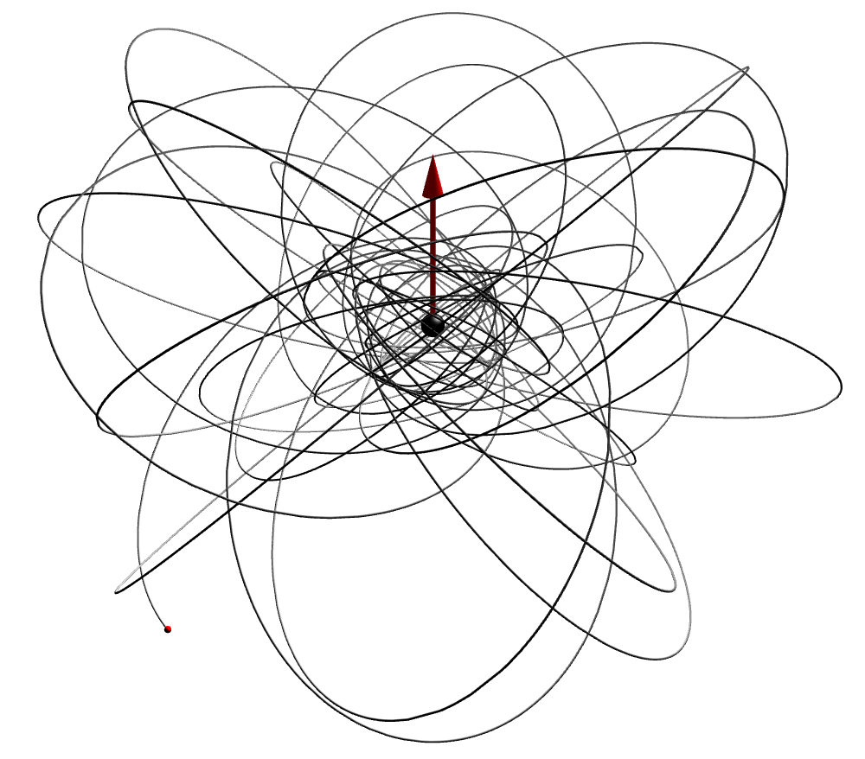
In 1964, Roy Kerr found another solution to Einstein’s Theory, one that extends the Schwarzschild solution to include a new phenomenon, spin! In effect, spacetime gets dragged along with the rotation, causing even more mayhem to our orbital path around the hole. This is known as frame dragging. There are an inner and outer event horizon, and even an inner and outer ergo sphere, within which it is possible to extract rotational energy. Moreover, a rotating black hole, spinning as fast as possible, has unstable orbits all the way out to nine black hole radii out going against the spin, yet can have stable circular orbits traveling along with the spin of the black hole, all the way down to the outer event horizon itself. Even so, the Kerr spacetime, reduces to the Schwarzschild spacetime, for a black hole that does not spin. The spin of the black hole, is what causes this so called frame dragging. As an example, the orbit of the earth around the sun, is a near circular ellipse. The constellations of the zodiac, are the stars on the far side of the earths orbit during that month. The path of the earths orbit traces a two dimensional plane, known as the ecliptic plane. For our rotating black hole scenario, this is no longer the case, as any non equatorial orbit about the black hole, tilts. That is to say that the ecliptic plane of our orbit is shifting like that of a spinning top on the table. This is even more wild than anyone could ever imagine!
Now imagine we have a handful of rotating black holes, all orbiting through a common spacetime, with their own masses and spins. At this point, we cannot solve the equations of general relativity directly, and will need to solve the equations on a supercomputer. Black holes spiral inwards towards one another and merge, releasing gravitational waves. These tremors in spacetime, then bend around other nearby black holes, which are merging themselves. Its just a gigantic mess of curved geometries. After a while, everything settles down to a few large black holes, with higher masses and new spins, all moving away from one another. In the theory of general relativity, matter tells spacetime how to curve, yet spacetime tells matter how to move. The matter we are referring to are the black holes themselves. Note that it is not just space or time itself that is bending, but our full spacetime geometry. This is the worldview we get, after unifying special relativity with universal gravitation.
To unify special relativity with quantum mechanics however, imagine two quantum marbles. You roughly know their distance and relative velocity after measuring them. Lets say we want to measure the separation between the two marbles, this time with a much greater precision. The uncertainty in the relative velocity of the marbles will have increased by a similar factor. By measuring the distance precisely enough, the uncertainty in relative velocity will exceed light speed. When this happens, you have discovered antimatter!
Going back to our two marbles, we know that they are actually two quantum waves. The mass of each quantum wave, is simply its own frequency. The year is 1925. Erwin Schrodinger finds a relativistic wave equation for these quantum waves. Weeks later, Klein and Gordon rediscover this relativistic wave equation, after Schrodinger abandoned it. These Klein Gordon waves reduce to special relativity and quantum mechanics, in their respective domains. However, Klein Gordon waves do things not seen before in science.
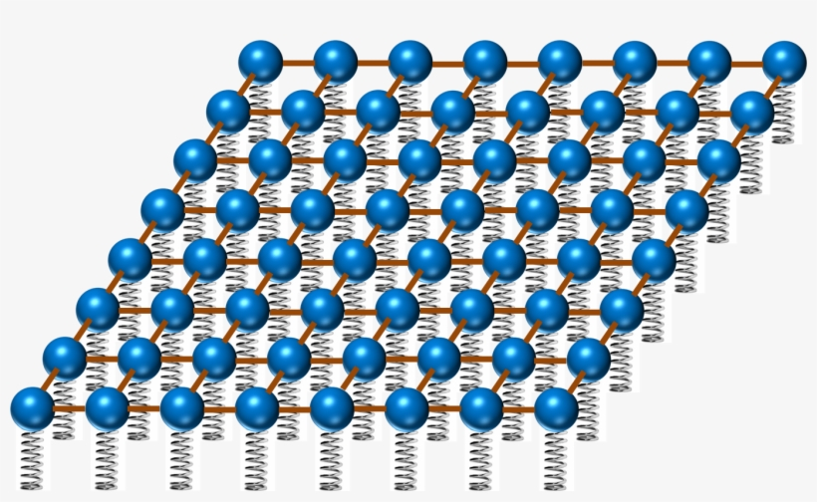
Just for fun, lets take a closer look at these Klein Gordon waves. Like all waves, Klein Gordon waves can be decomposed into a series of plane waves with definite frequencies and wavelengths. Take one of these plane waves for example. It is called a plane wave for a reason. Simply because as the wave scrolls through space, it has wave fronts that are flat two dimensional surfaces, or planes. The perpendicular distance between the parallel wavefront planes, is the wavelength. The frequency is just the number of cycles per second. So in other words, a plane wave is the building block of any wave. Lets now boost to a moving perspective, such that we are moving with the wave. At this point, the wavelength is so long, that for our purposes, the plane wave is now a synchronized sine wave. Its like the tides going in and out of the shore, as the whole flat ocean seems to rise and fall every day, in perfect unison. As we boost to a slowly moving perspective, the frequency has increased very slightly, however the synchronized wave is now out of sync again, as another plane wave, with a very long wavelength. At such slow speeds, the frequency of the waves is fairly constant, and could be ignored. The remaining phase angle of our wave, now has a much lower frequency, now in proportion to the kinetic energy of its associated quantum marble. The inverse wavelength of our nearly synchronized plane wave on the other hand corresponds to the linear momentum of our marble. As we boost away with faster and faster velocities, the wavelengths of our plane wave get shorter and shorter, and the frequency increase becomes noticeable. As we boost much faster, ever closer to light speed, the plane wave now has a very high frequency and a very short wavelength, such that the plane wave now seems to travel at exactly the speed of light. Boosting more will only make the waves even shorter, as they continue to travel at exactly the speed of light.
In 1928, Paul Dirac found another relativistic wave equation, one that extends the Klein Gordon equation, to include a new phenomenon, spin! The spin of the Dirac waves, is due to a new direction that these waves can vibrate in. In some sense, the more ways in which these quantum waves can vibrate, the greater the spin. Spin can only increase or decrease by half steps. In this case, we have a spin up and spin down electron, along with a spin up and spin down positron. Each and every component, are themselves Klein Gordon waves. It is only when we change our point of view, that the components mix into one another. For example, take a Klein Gordon plane wave vibrating purely as a spin up electron. If we rotate this wave, and look at it from another angle, the plane wave, with everything else being the same, is now vibrating as a spin down electron. Similarly, if we boost our whole setup so far, the vibration in the first two matter electron components, is now slightly vibrating the last two antimatter electron components also, also known as the spin up and down positrons. We say that Klein Gordon waves and Dirac waves, have the spin that they have based on this simple idea. Klein Gordon waves have a spin of zero, because if we rotate the setup by a full turn, everything stays the same. This is obvious. However, if we rotate a Dirac wave by a full turn, the components mix only half of what we expect. This means that it takes two full turns of a Dirac wave to return to its initial configuration. We say that a Dirac wave has a spin of a half, for this very reason.
Now imagine we have a bunch of Klein Gordon and Dirac waves, all undulating independently throughout spacetime. Every quantum wave, vibrates in its own abstract dimension, with every dimension corresponding to the probability coordinates of every marble. This is similar to how the spin of all these marbles acts like. The Klein Gordon waves, overlap and build up, whereas the Dirac waves interfere and sometimes cancel out. In this theory, it is all about a new entity called a relativistic quantum field. Imagine a crystal array of quantum marbles that extends out to infinity in all directions. If we hit this crystal with a hammer, it will vibrate just like a big block of rubber. As it turns out, these vibrations are completely identical to our Klein Gordon and Dirac waves. Since these vibrations are nothing but sound waves living in a crystal lattice made of quantum balls and quantum springs, there should be a minimum unit, or quantum of a field. As luck would have it, every field quantum acts independently, just like a marble. Therefore our system of a bunch of Klein Gordon and Dirac waves, is thus nothing more than a collection of field quanta. This is our worldview after unifying special relativity with quantum mechanics.
Our two worldviews, one of the heavy, and the other of the light, both share some common features. Black holes and quantum waves, both have mass, and also both have spin. Because of this fact, a setup of the exact same physical system in one worldview, will mimic the behavior in the other worldview. It turns out that the atoms and subatomic particles, of which we are made, are not marbles at all. They are instead a kind of quantum black hole. A quantum black hole, behaves more like an actual black hole if it is really heavy, yet also acts like a quantum wave if it is really light. Therefore, in order to understand this, we needed to unify the three pillars of physics into a single framework. This means that everything is one. Literally!

The Mathematical Details:
The Symmetries of Minkowski Spacetime

GC with spin: The Kerr Spacetime in the cartesian Kerr-Schild Geometry

HC with spin: The Dirac Equation and other Relativistic Wave Equations

CGH physics for a particle with spin

Practice Questions:
3a). Run a simulation of a test geodesic in the given Kerr Geometry. Show how the geodesics reduce to that of both special relativity and of universal gravitation, and demonstrate their behavior by changing the mass and spin paramaters accordingly.
3b). Run a simulation of the given Dirac equation in Minkowski spacetime using a fourier pseudospectral solver.

Theory Four: How Everything Arises From Nothing

The spacetime of special relativity, called Minkowski spacetime, has certain symmetries, known as Lorentz Transformations. They keep the speed of light constant, under a change in perspective: The relativity principle. They are the symmetries of spacetime itself: 3 Hyperbolic Boosts, 3 Spacial Rotations, 4 Spacetime Translations. From these symmetries, emerges new phenomena.
In classical field theories that involve relativistic wave equations, which live on Minkowski spacetime, the mass and spin of these field equations, are a direct result of spacetime symmetries. Mass is the minimum frequency for a wavepacket at rest. Spin is the amount of change between field polarizations under a change in spacetime perspective. Due to the quantum principle, the mass and spin of a wavepacket, when zoomed far enough away, appears to act like a spinning top, with the mass being the top’s inertia, or resistance to changes in motion, and its spin being its angular momentum while spinning.
However, all relativistic wave equations, still live on flat Minkowski spacetime. Sure, there could be interactions between fields that give rise to non-gravitational forces. This is what the standard model does, as it is a classical field theory, that maps out the possible interactions between wavepackets. However, in Einstein’s General Theory of Relativity, gravity is the result of the curvature of spacetime itself. Therefore in General Relativity, spacetime is a classical field theory in its own right. The reasoning to this approach is astonishing, because one has to invent a new way to produce classical field theories involving symmetries.
The answer is a new kind of symmetry known as local symmetry. So far, relativistic wave equations had global spacetime symmetries: Mass and Spin. However local symmetries are symmetric only in small regions of the field spaces. We already encountered local symmetries in the standard model. They were not local spacetime symmetries, but local field symmetries. However, one might ask what happens when one makes spacetime symmetries local in their own right. The answer: General Relativity!
Okay not quite, as I must admit. Although General Relativity is a classical field theory, where spacetime curvature gives rise to gravity. It doesn’t have all of the local symmetries of spacetime. Only spacetime translations become local symmetries in Einstein’s theory. However, what we are asking is what happens when all spacetime symmetries become local symmetries. In the general case scenario, one must intoduce a new concept known as torsion… Just like energy density currents and momentum density currents couple to gravity, spin densities couple to torsion. And, just like how the curvature of spacetime is the definition of gravity, torsion has to be included to make sure the boost and rotation symmetries are also local in nature. The result is a new theory called: Poincare gauge theory, or gauge theory gravity, which has field equations known as the Einstein Cartan Theory.
However, in our theory, we are not to couple the fields of the standard model to the einstein cartan theory. And here’s why? Solutions of the einstein cartan theory produce black holes, whether or not we couple other fields to the theory. I mean why not let everything be fields, including spacetime curvature and torsion, and what is the deal with black holes? This is a bug, not a feature. Black holes have to be associated with a point particles… And as we know, point particles do not exist. At least in classical field theory. But, in this oberservation comes a truly surprising result.
As we know we applied quantum physics to a single point particle, and recovered a classical field theory of relativistic wave equations. Therefore, if black holes are also points, means one thing: Every rotating black hole with a given mass and spin, must be associated with a discrete field quantum of a relativistic wave equation! And, in our einstein cartan theory, which we just coupled to the standard model field theory doesn’t do it justice. Black holes exist regardless of field content. What we need is a theory where black holes exist, only when the fields are vibrating, and when no fields are vibrating, there shoudn’t be any black holes present. Moreover their mass and spin should also be completely identical. How to do this?
Since Minkowski spacetime has the same global symmetries, even in the case with the Einstein Cartan theory, there shoudn’t be any extra local symmetries. By coupling the standard model to it, we included plenty more extra symmetries that the Einstein Cartan theory couldn’t handle. Let me say it backwards: All local symmetries have to have global symmetry counterparts. And in the standard model, we only have a global spacetime symmetry, there are no global field symmetries. Therefore, lets keep the standard model and the Einstein Cartan theory separate, for now.
Thus, in the vacuum, the Einstein Cartan theory, reduces back to good old General Relativity. How? Without any mass or spin present from other field theories, the right hand side of the Einstein Cartan theory vanishes. Spin vanishes, and so does the mass. Torsion is algebraic, so it completely vanishes without spin, leaving us with general relativity. But in general relativity, the energy momentum tensor is also all zero, due to vanishing mass. Therefore, one is left with general relativity without any sources.
In vacuum general relativity, there are plenty of solutions. One can consult a numerical relativity simulation, just to be sure… rotating black holes orbit and collide, gravitational waves propagate around everywhere. And, everything is just vacuum. So clearly, one has sources without a source, particles in vacuum, or otherwise put: Everything from nothing!
What we need now, is a way to directly couple these rotating black hole solutions, to our discrete field quanta. We need a way to produce the spacetime geometry straight from its solutions, and not the other way around.
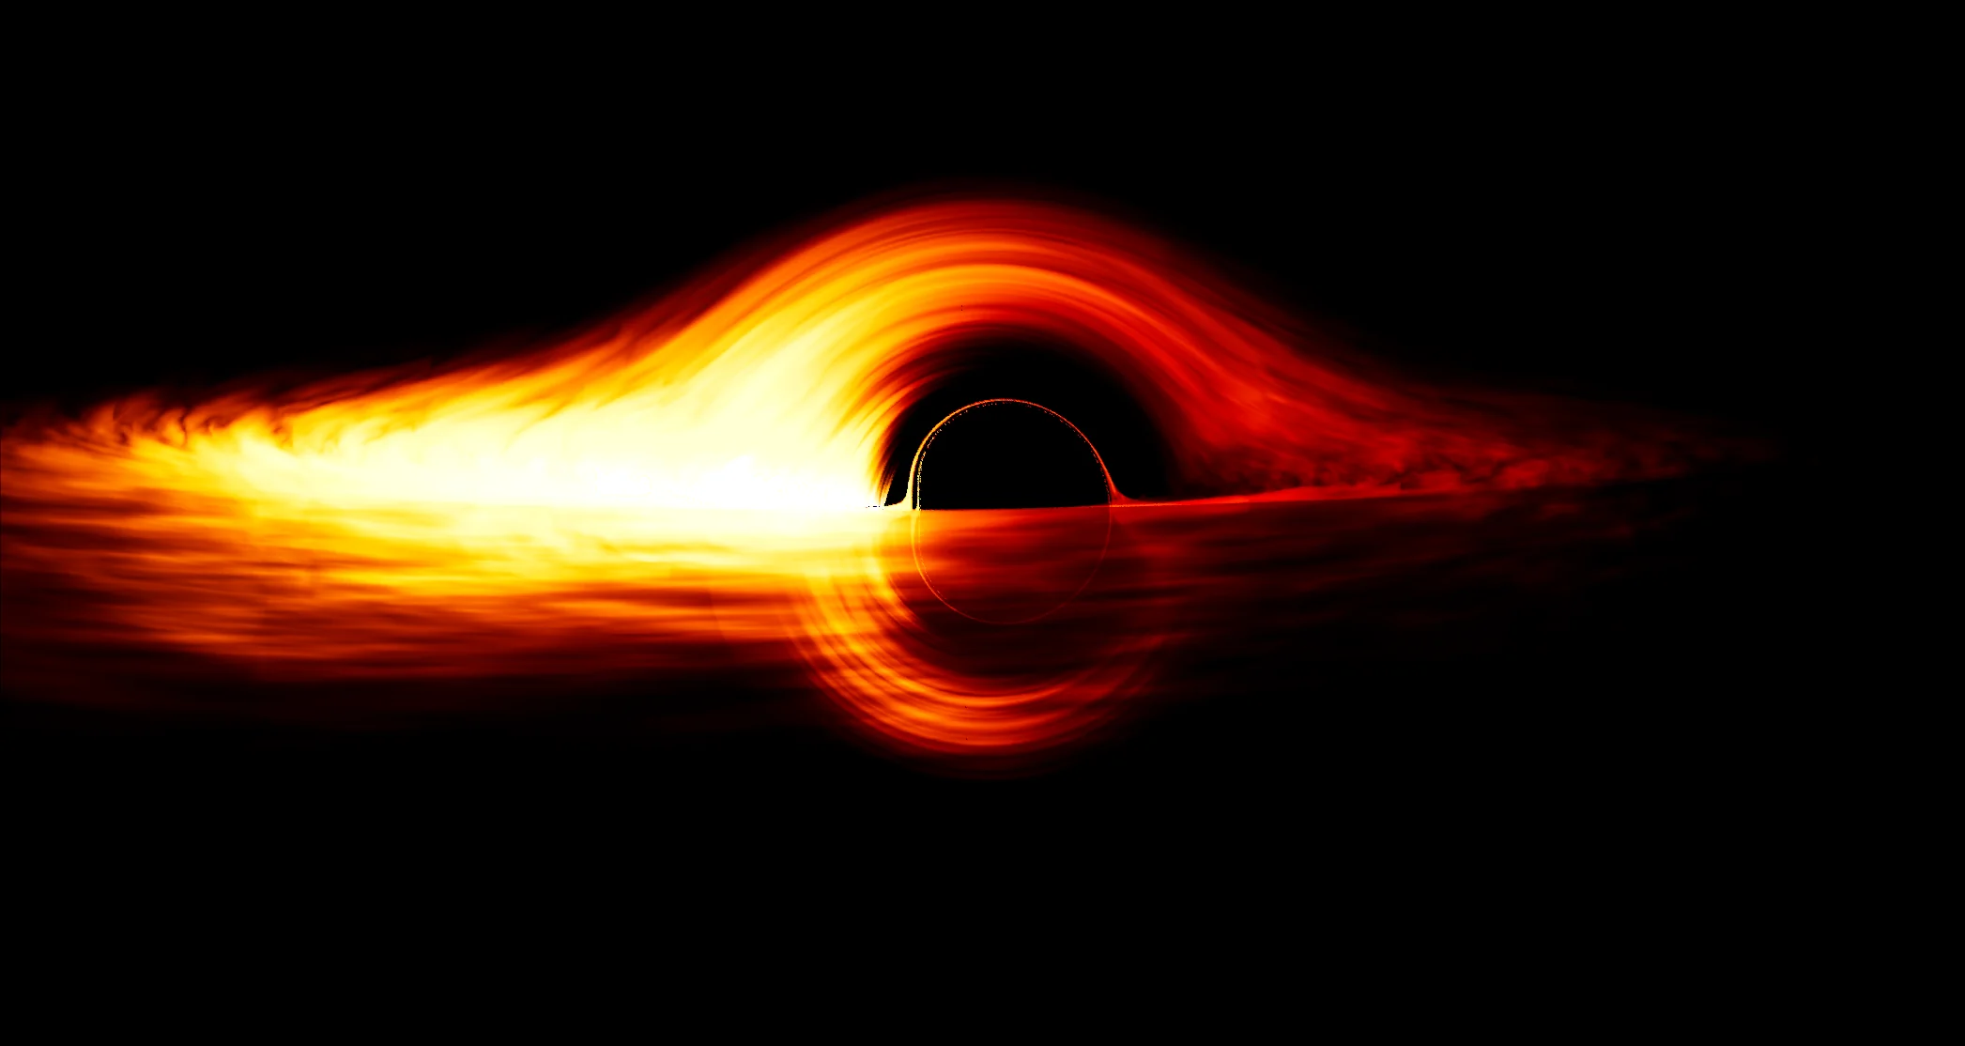
Enter the cartesian Kerr Schild spacetime geometry! In laymans terms, it is the spacetime geometry for a rotating black hole in orthogonal light cone coordinates. They have some nice properties, such as being exactly linear solutions to vacuum general relativity. They have constant metric determinant, are lorentz transformed solutions of one another, and in these coordinates, the vacuum einstein’s equations, becomes a simple tensor relativistic wave equation. Everything is exactly linear! No gravitons, no renormalization, no issues, just solutions that coorespond to point particles. And since, these solutions are the result of a exactly linear coordinate system, tells us that the superposition principle still holds. Therefore, one can reconstruct the entire spacetime geometry in the Kerr-Schild form.
What is needed now, is to propagate the standard model as a classical field theory over this curved background geometry. We introduce covariant derivatives for all fields. However for the matter fields which use Dirac spinors, there is a sublety, which needs to be addressed: We need the spacetime frame instead of the metric tensor. Luckily Kerr himself, used the so called tetrad approach to produce his spacetime geometry for a rotating black hole. In some research articles, it has been reproduced in cartesian Kerr-Schild coordinates. Using a set of light cone adapted null geodesics, one can produce the correct tetrad frame field.
Therefore to conclude the theory of everything, the standard model is a classical field theory. A consious observer collapses the field to discrete mode amplitudes. Then the collapsed field acts as a single pilot wave, that carries multiple trajectories, with each path being a singularity. The Kerr metric or kerr tetrad is computed for each singularity, in Minkowski spacetime. The fields propagate through this curved spacetime geometry, and the computation loop closes. This is what is required so that a computer simulation can be performed for the entire universe.

The Mathematical Details:

Practice Questions:
4a). Derive the Vacuum Einstein Equations from Poincare Gauge Theory Gravity by setting both the spin density and energy momentum tensors to zero.
4b). Show that the Kerr metric in the Cartesian Kerr-Schild coordinates satisifes an exact linear version of the Einstein Equations.
4c). Run two simulations and compare their efficiency, with the first simulation being a numerical relativity code that solves the field equations directly, and the second simulation using the Cartesian Kerr-Schild coordinate system to superimpose Tetrads for the Kerr Spacetime Solution, with singularities as trajectories producing the gravitational field in the retarded time for the accelerated particle.
4d). From the simulation results, deduce that vacuum solutions do indeed support a particle interpretation with the Kerr metric parameters as the Casimir invariants of the system.

Theory Five: The Many Failures of Quantum Particles

What is a particle? Newton thought that particles are tiny points. Even Einstein’s theory predicts black holes as points. However by that time, science has caught up, but every scientist continued to believe in point particles. Even with the birth of quantum theory, the point particle persists. Why? Could we be wrong all along? The answer is a resounding yes. As it turns out, reality is not made of particles at all… But something else: a field!
To really see the significance of such a paradigm shift, we first need to come to grips with what a quantum particle even is. Every quantum theory begins with a single equation: The schrodinger equation. This equation is what one gets when one applies quantum physics to a single particle. In other words, it is the quantum version of Newton’s point particle! Interpretations aside, the schrodinger equation is actually a field equation. A field is just a mathematical object that takes a value at every point in space, just as a particle is a mathematical object with a position in space. It is that simple. But, the details matter here, such as why the schrodinger equation has so many people baffled about what a particle is.
For quantum physics 101, we recall how to apply quantum physics to a point particle. Back in classical physics, we know a particle is an actual point that travels in a straight line with a constant speed. Just like a billard ball. It has linear momentum, and kinetic energy. The momentum is just its mass times its velocity vector. Whereas the kinetic energy is simply half of the dot product between its velocity and its momentum. However, the shrodinger equation tells the same story, with a central modification. The solutions of the equation are now sine waves, with their wavelength inversely proportional to their momentum, and their frequency directly proportional to their kinetic energy. By adding many sine waves together, one can create wave packets: Traveling waves that look like a collection of point particles from a great distance.
However, most scientists didn’t see it that way. They invented a slew of new methods to coax particles out of the wave equation. Lets examine each case, one by one. So here we return to our original question: What is a particle?
One way is to reinterpret the wave equation as describing not a field, but a probability wave, known as a wavefunction. The amplitude squared of the wavefunction gives the probability density of finding the particle in space. Therefore during measurements, the wavefunction “collapses” to a single point of interaction. This collapse gives us the definite position for our point particle. But this gives new problems. Since the collapse is a result of a single measurement of a single particle, means one thing: One must introduce new dimensions of space to handle more particles… 1 particle is 3D, 2 particles is 6D, 3 particles is 9D, 4 particles is 12D, and so on… This phenomenon is known as quantum entanglement, or spooky action at a distance. And this is used to compute corelations between multiple particle probabilities.
Another way is to keep our original interpretation of the wave equation as describing a field. From this, we apply the whole procedure of quantum physics all over again, not to our point particle, but to the entire field! The “quantum” field as it is called, has an infinite number of dimensions, each one describing the value of the field at a particular point in space. Each sine wave in the field, has a physical amplitude, just like the position of a particle. Therefore, the resulting “quantum field” is an infinite collection of coupled quantum harmonic oscillators, and is no different than our original use of wavefunctions for describing the system. Then, the energy levels of each quantum harmonic oscilator, corespond to a collection of identical quantum particles. From this, we have come full circle, as “quantizing” the field, gives the same result as reinterpreting the field as a multiple particle wavefunction. Something seems off here, due to the persistence of point particles.
The reason for using quantum mechanics then has nothing to do with the shrodinger equation itself, and rather is all about the probabilities of measurements having to do with some sort of wavefunction, which lives in an abstract space of possibilities known as a hilbert space.
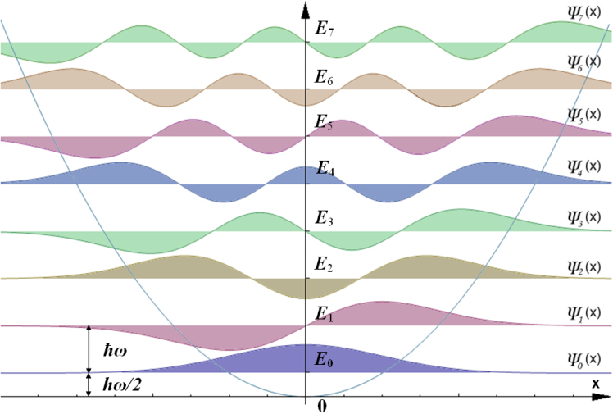
We should pay attention to what the schrodinger equation is actually describing, and not force particles into our paradigm. By doing so, we lose track of what reality is, as human centric constructs enter our most fundamental theories. Particles are just one example of this. In everyday life, we see solid objects in motion: Particles. And objects move through a physical medium: Space. If particles are such a human centric construct, we have to make sure that this doesn’t creep into physical theory…
However, there is more to the shrodinger equation than this! Every relativistic wave equation, reduces to the shrodinger equation in the domain that the speed of light becomes instantanious. So, if the shrodinger equation describes a field, and this field is what one gets in this regime where the speed of light tends to infinity, means one thing: All relativistic wave equations describe fields too!
And it is this idea which makes some serious sense. Here’s why… The standard model of particle physics, believe it or not, is a field theory. If one took the field equations, and run them on a supercomputer, that would be all that is needed to simulate the universe. The fields equations are just relativistic wave equations, or otherwise put, versions of the shrodinger equation, that obeys Einstein’s theory of special relativity. In the regime where the speed of light becomes instantanious, does one recover the shrodinger equation. Therefore the shrodinger equation is not fundamental to quantum physics, but instead, all of quantum physics including the shrodinger equation emerges from relativistic field equations. Classical Field Theory is more fundamental than Quantum Mechanics! And the standard model, is exactly that: a classical field theory. Since quantum theory is emergent, there is no need to apply it to a theory which is already “quantum” in nature. Therefore the standard model is a theory which satisfies both quantum physics and relativity. It’s that simple!

The Mathematical Details:

Why Second Quantization Fails

Why Particle Scattering Fails

Why Wavefunction Collapse Fails

The Answer: It is a Field Equation

Practice Questions:
5a). Quantize the 1D klein gordon operator, and write it’s excitations using feynman diagrams.
5b). Show why a 3N+1N hilbert space is necessary for describing the quantization of N relativistic particles.

Theory Six: Why Fields Are Fundamental

In standard quantum field theory, one promotes field values to operators that act on a wavefunction of field configurations. However, as we know, this leads to issues related to the fact that standard quantum theory is an emergent phenomenon. So what do we do? We see particle trajectories in particle colliders, atoms in electron microscopes, and photons of light in the photosensors of a digital camera. What is going on here?
The answer might not be what you expected, since reality is all classical fields, we cannot afford to reintroduce quantum theory, to make particles pop out. Moreover, the introduction of quantum physics to matter fields like the Dirac equation, leads to other issues like the use of anti-commuting variables. These “numbers” don’t have a wavefunction associated with them, so altogether, we lack a particle interpretation anyways, and the fields are treated inconsistently. However, there is a loop hole.
Whenever we see a “particle”, what is going on is that the field has been localized. After all, wave packets, do act like particles. What if, it is possible for fields to collapse. Not like wavefunction collapse, but in a different way, that I call field collapse. This is similar to a Jpeg image file. The image is the field. One takes the fourier transform to find the frequencies that make it up, and then rounds their amplitudes. The result is stored on the computer’s storage drive. This introduces discrete amplitudes, for all field modes. What we are doing is much the same.
To be rigorous, there is a theory known as the old quantum theory. Each fourier mode of a field is just a sine wave, as we discussed previously. Since these sine waves are solutions to a simple harmonic oscilator, we need to find the “old quantum” counterpart. The process of quantizing the harmonic oscilator, in standard quantum theory only produces the wavefunction for bosons, not fermions. However, the old quantum theory does describe both bosons and fermions. For bosons, one has the commutation relations, and for fermions, one has the anti-commutation relations. These are the same relations that gave us the anti-commuting numbers, and harmonic oscilator wavefunctions. But with a twist…
Instead of quantizing everything, we discretize everything. Since all fields are relativistically invariant, one only needs to quantize a field mode in its rest frame, and then one can lorentz boost to any other frame. This ensures that the field mode amplitudes are all unchanged by a change in perspective. Thus a field mode at rest, is just a single sine wave, vibing at a frequency of its rest mass energy.
Applying the old quantum theory to such a sine wave, one selects amplitudes whose square is an integer. Just like the wavefunction squared gives a probability that integrates to one over all spacetime, here the total value is an integer, as we are dealing with multiple levels of energy, each one a discrete field quantum: A particle.
What makes this interesting, is that the transition matrices used for quantizing a harmonic oscilator, are the exact same that are used for the discrete harmonic oscilator. For field theory, these are the raising and lowering operators. But here, we are using these matrices to select discrete amplitudes for our field modes. The amplitudes are all square roots of the integers. For bosons, the whole numbers are allowed. For fermions, they are the binary numbers which are allowed. Therefore Qbits, in quantum computing, are just these anti-commutation relations.
So, from this, one can discretize the field modes. But a question arises, how does this reproduce the Pauli exclusion principle, and the stats for particle exchanges with varying degrees of spin? Since each fourier mode, has an uncertainty principle built in, with each sine wave having a definite momentum, implies that matterial fermions must take up space. Why? Since the mode amplitudes must be binary, and since they are states with definite positions or definite momenta, but not both, means that cannot overlap, because this would mean the ampltudes would be greater than one. Therefore, the exclusion principle is derived directly from the anti-commutation relations used not to quantize but to find discrete binary amplitudes for each field mode.
For bosons its a similar story, as their harmonic oscilator amplitudes are all resulting from the use of commutation relations. The same statistics, the same polarizations, the same exclusion principles, the same everything as the standard theory, but just a discrete classical field theory. For the spin stats, one must realize that it takes two full turns for a spinor to complete its rotation, but a vector takes just one full turn to do its rotation. This is the same reason why the exchange symmetry works for both bosons and fermions. Whenever we observe a field, it takes on discrete values. But what discrete values does it take?
Imagine the setup. You reading this, are in a simulated virtual universe. The VR headset tracks your movements, and the screens update. Its the same here. The fields you see are discrete because of the VR headset. Without you being here, the fields will continue their evolution determined only by previous updates. Therefore as soon as consious observers evolved on our world, the spaceship earth, was the time that the fields started to collapse to discrete values.
The collapse rules are as follows: 1). Bosons and fermions both have fields that before collapse can take on any field mode amplitude all real valued. 2). Bosons have amplitude A = sqrt N, where N = 0,1,2,3,etc, and their collapses occur with a poisson distribution to any N. 3). Fermions have amplitude A = 0,1, where N also = 0,1, and their collapses occur with a bernulli distribution between N=0,1. 4). Fermions and Bosons both share P(N=0) = exp(-A^2). 5). Phase angles for the field modes, follow the relativistic bohmian trajectories on the field, and are updated to the trajectory's positions a priori, and not just follow the field's mode' phase angle at all times, after collapse.
Now that we have a method for finding our discrete field quanta, its time to use our single classical field theory. In Bohmian mechanics, or pilot wave theory, there is a wavefunction that guides a single trajectory in hilbert space. The gradient of the wavefunction in each of the dimensions gives the momentum of the cooresponding particles. In our theory it’s similar with another twist…
Previously, we abandoned quantum theory, and replaced it with a discrete but classical version. So to be compatible with our theory, we have to redefine our pilot wave theory not for a wavefunction, but for our field theory. Now, we still use the same gradient rule, but replaced with a field. Now since there are not 3N dimensions anymore, its seems natural to just let our single field theory, guide multiple independent trajectories. Not, a single trajectory on a high dimensional wavefunction. But rather is this: Many particles guided by a single field theory!
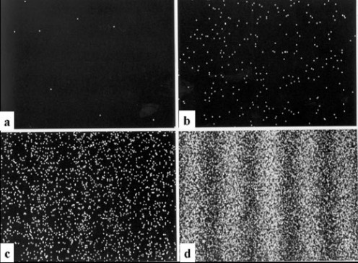
Here, everything seems fine, so what happens to quantum entanglement and exchange symmetries? Since the field modes are discrete, and since non locality is generated by the trajectories, not the field, means that every particle is indeed coorelated with every other particle. Lets take a closer look to a famous experiment. The double slit experiment!
Here particles are shot into a wall with two slits in it. The particles are detected on a recording screen behind the wall. Since the particles are all wave packets, means one thing: We see an interference pattern on the back wall. The same thing occurs with single particles too. Its only when a single particle is observed before it passes through one slit or the other does the pattern split into a two band pattern of hits, not an inferference pattern of many bands.
What is going on? Are there some spooky things going on? Nope, wrong again. The field theory describes the same thing as the quantum theory, because the field equations are identical to the shrodinger equation. Even for a single particle quantum theory, its the same… And thats why an interference pattern is seen, even when struck one particle after another!
But now, something interesting occurs when one observes it before it passes through. Everything the same, the discrete field theory, collapses just like the wavefunctions do. Therefore its no difference what theory we use, but the field approach is much simpler, and thus must be the correct one!
Turn down the intensity, and fewer particles pass through the experiment at any given time. The field discretness becomes more visible. Until one discrete field quantum is passing through any given time. The pilot wave trajectories are used because the discrete field behaviors are what encodes the multiple particle exchanges. Without the entanglement directly encoded in the wavefunction’s phase space, we are free to include multiple trajectories in our field theory. After all, when we turn the intensity back up, we recover the trajectories as actual particles. It’s just the fields themselves collapsing, creating the illusion of particles. Here is how this works:

1). Take the standard model of particle physics. As sean carroll's core theory, it is a domain specific truth, verified to a great undreamt of precision. Specified by a lagrangian density. Next, Reinterpret it as a classical field theory. Use the relativistic field theory version of the euler lagrange equations, to derive the equations. Then solve them numerically using a fourier pseudospectral method.
2). Introduce discrete field collapse using old quantum theory and the canonical transition matrices. Just like a harmonic oscilator in the old quantum theory, every plane wave decomposed field mode has discrete classical amplitudes, which are lorentz frame independent. Using canonical commutation and anticommutation relations to derive bosonic and fermionic heisenberg matrices, one can recover the transitions through the coorespondence principle. Not by canonical quantization, but by associating transition matrices with probabilities for discrete field mode amplitudes. For bosons one uses the simple harmonic oscilator in the # basis. For fermions one uses the 2 state quantum system in the Qbit basis. Therefore quantum wavefunction collapse is just the collapse of a single classical field to a superposition of multiple VR consious interaction events. 3). Each discrete classical field quantum is associated a relativistic bohmian trajectory. Not using quantum entanglement nor using feynman rules, which is wrong since they use a single trajectory in 3N+1N dimensions projected down to all N particles. Rather we use a single classical field theory guiding our N trajectories independently. The pauli exclusion principle occurs from the 1st order spinorial nature of the Dirac equations and the lack of it occurs from the 2nd order vectorial nature of the Proca equations. Thus the spin statistics theorem is derived from the fourier modes of collapsed field modes guiding our bohmian trajectories, think of the exchange symmetries but applied to the double slit experiment as a CFT(Classical Field Theory).
4). Each trajectory using the Kerr NP(Newmann Penrose) tetrads in the cartesian Kerr Schild spacetime geometry, sources the spacetime geometry from flat Minkowski spacetime, using the Poincare Gauge Theory, and with it the classical fields are coupled to this geometry. This goes full circle and completes the code. The point is simple, every discrete classical field quantum is by definition a rotating black hole. Using the xKS(cartesian Kerr-Schild) coordinates, one can perform Poincare transformations to spacetime frame hop from one bohmian trajectory in its own retarded time to the other's trajectories calculated from the exactly linearly perturbed classical fields surrounding it. From a global minkowski spacetime with Poincare symmetries, mass and spin, one gauges the symmetry in vacuum resulting in the Kerr geometry, which you guessed it describes particles with mass and spin. In a sense we got everything from nothing. A Theory Of Everything!

And from nothing emerges everything. The only assumption we made was that of spacetime symmetries. By applying CGH physics to this void, we learned that rotating black holes and discrete field quanta are one and the same. From the field dynamics we can build our universe. Our universe is all there was, all there is, and all there ever will be.
However, with this said, there is still plenty of work to still be done. We need to see how the theory of everything applies to our universe. We will learn that all everyday phenomena arise from the motion of atoms in the void, governed by a given inter-molecular potential. From this we can deduce similar processes occuring in deep space, and show how everything from the most common elements to the structure of atoms themselves came about from events that occurred fractions of a second after the big bang itself: 13.8 billion years ago.
We ourselves are a byproduct of the universe’s existence, so it’s really no surprise that we found ourselves in a universe such as this. The trick is to understand our universe by being able to show that the theory of everything does indeed give rise to the universe we see around us. After all we and everything else follow the same rules. The question then is: What are those unbreakable rules that the universe always obeys to the letter.

The Mathematical Details:
For Fermions of Matter

For Bosons of Force

Fermions Anticommute

Bosons Commute

The Field Collapse Math

Practice Questions:
6a). Show that the creation and destruction operators have the matrix form shown above. Prove that the relations hold.
6b). Run a classical field theory simulation of the Dirac equation, and demonstrate that its wavepackets move independently like a collection of spin ½ fermions would also move independently.
6c). Apply the old quantum theory to the Dirac equation and using the anti-commutation matrices for field collapse. Show that this classical field collapse method works more efficiently than the standard quantum operator approach for particles, yet gives the same results as standard quantum theory too.

Theory Seven: The Theory of Everything

The theory of everything, is all about a material. The aether! Within, exist a chaos of sound waves. As they undulate across space, their vibrations propagate in all sorts of exotic ways. All of this happens automatically, without any sort of divine intervention. The fact is, that the whole cosmos is entirely built out of these waves. In order to find out what these waves can do, lets first analyze their physics. In so doing, we will learn about all of the complex and intricate structures that these waves can form. This truly is, the theory of everything!
As it turns out, a wave can only affect other waves nearby. This means that it takes some time for a wave over here, to influence a wave over there. The sphere of influence grows at a constant speed. This speed is the speed of light. Since light speed is always the same, means that from a moving perspective, it is time itself that runs slow. As such, space and time are unified into a new framework. Spacetime!
Imagine finding a concentrated lump, or packet of waves. Seen from far away, this so called wave packet, looks very much like a dot, moving in a straight line with a given speed. A particle. However, “particles” act very strangely at microscopic distances. They act randomly, yet also are in many places at once. How can this be? This is because they are not particles, but waves. After all, waves are spread out entities. So it makes sense why particles seem to act like this.
Moreover, these matter waves can also experience forces, meaning that they can push and pull on each other. This happens, because waves of matter and waves of force, can interact. If we take two matter waves, placed some distance apart. They might attract one another, because both matter waves are disturbing the waves of force in between.
So, given this, waves of matter and waves of force can act very differently. Matter waves, have a property called mass, whereas force waves do not. All waves with shorter wavelengths, tend to vibrate with a faster rate, or frequency. It is this excess frequency, in addition to its frequency due to its wavelength, that is the mass of the waves. This is the reason why some waves, have the property that they can vibrate faster, yet be very spread out. These waves are our matter waves.
However, there is more! Mass isn’t the only property that waves can have. Waves can also have a property, known as spin. That is to say, that the direction that the waves are vibrating in, its polarization, depends on our point of view. The amount of spin, takes on discrete values, of zero, one half, one, one and a half, two, and so on. For example, we say that, matter waves are spin half, because it takes two full turns for their polarization vectors to take one full turn. On the other hand, force waves are spin one, because under a full turn, its polarization vectors also take a full turn. Otherwise put, the more ways, or degrees of freedom, the greater the spin.
But, what about particles? It turns out, that all of these waves are actually sound waves, vibrating within a material called the aether! The aether has the property, that it cannot just vibrate with any given intensity. The sound energy, or loudness, comes in chuncks, known as quanta. By definition, every quantum is a particle. The quanta of our matter waves are electrons, particles of electricity. The quanta of our force waves are photons, particles of light. That’s not all. Every particle is a wave of probability. An electron’s probability wave, is exactly identical to its matter wave. Similarly, a photon’s probability wave, is exactly identical to its force wave. The same applies to every particle in existence. This is where the similarity ends. For many particles, we need to know the combined probability, of finding all the particles at all of their positions. The fact is, since all particles of the same kind are completely identical, means that it is impossible to tell them apart. Because of this, our combined probability, can either add or subtract, when we swap two particles. Electrons are fermions, because their probabilities subtract away. On the other hand, photons are bosons, since their probabilties add together. Surprisingly, particles with odd multiples of spin half are all fermions, and those particles with even multiples of spin half are all bosons.
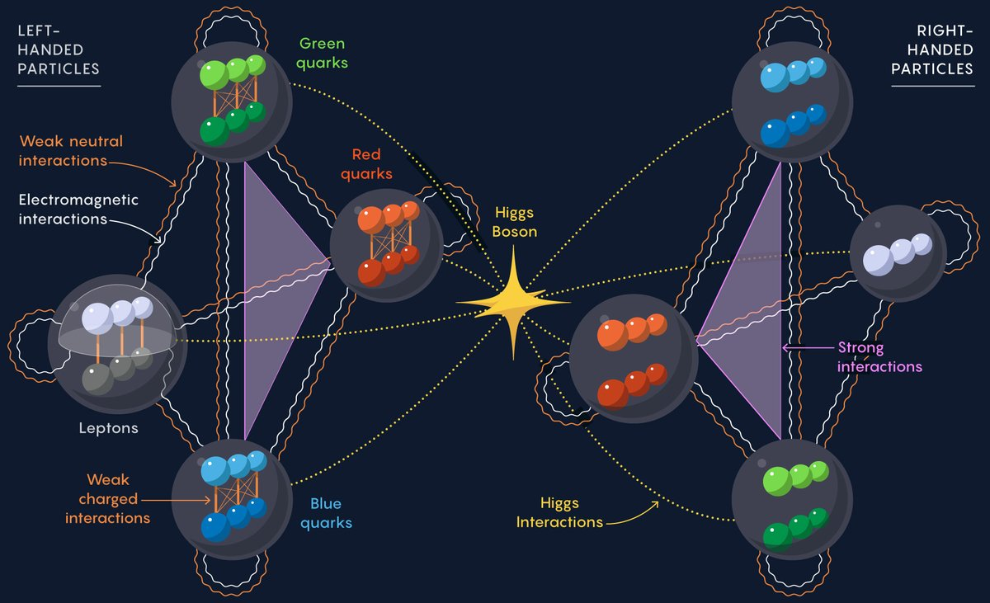
Imagine the scene. Within spacetime, all kinds of waves, with all sorts of exotic properties, are all interacting in every possible way. It’s pure chaos! The violence of this mess of particles is just insane. Particles smashing into other particles. Its all about how these particles behave. Therefore lets now take an inventory of all the particles.
We have already met the electrons and the photons. Electrons interact with photons, because they have a property known as the electric charge. The electric charge of electrons is either positive one or negative one. The matter electrons are all negatively charged. The positively charged electrons are the opposite of matter, known as antimatter. Matter particles and antimatter particles can cancel eachother out, in a violent release of light energy. We say that photons, particles of light, are carriers of the electromagnetic force. After all, light waves are electromagnetic waves. Photons are themselves electrically neutral. The electric charge is not the only charge that exists in the cosmos. There are two others, the flavor charges, and the color charges.
There are four flavors of fermions, the up and down quarks, and the charged and neutral leptons. The electrons are an example of charged leptons. Every up quark has an electric charge of positive two thirds, and every down quark has an electric charge of negative one third. Like electrons, the antimatter quarks also have opposite electric charges. Just like how photons interact with electric charge, there are three other bosons that interact with the flavor charges. These bosons carry a force known as the weak nuclear force, and interconvert flavors into one another. Unlike photons, which do not self interact, the bosons which carry the weak nuclear force, certainly do self interact. We call these bosons, the W plus, the W minus, and the Z zero.
Then there are the color charges. Quarks are the only fermions with color charge. They come in three varieties of red quarks, green quarks, and blue quarks. The gluons interact with these three color charges. They carry a force, known as the fundamental strong nuclear force. The leptons no not experience the strong nuclear force, because they are color neutral, and as such, do not interact with gluons. Gluons, like quarks, have a color charge. In fact gluons come in eight varieties, with each kind of gluon having a unique color charge. This means that like the W and the Z bosons, gluons self interact. Gluons have a color charge of a given color, say red, and a given anticolor of a different type, say anti green. So a possible color charge for a gluon is red anti-green.
As usual, there is more to it than this. Each flavor of fermion, has three possible amounts of matter, or mass. The up type quarks, are the up quarks, charm quarks, and top quarks. The down type quarks are the down quarks, strange quarks, and bottom quarks. Electrons also have two heavier versions, the muon, and the tau. Why? The answer is the interaction with a particle known as the Higgs boson. It is very heavy, and has an unusual spin of zero. All of the other bosons, interact with charges, and have spin one. The higgs bosons don’t carry forces, but they do give mass to the other particles that have it. There are exceptions though. The neutral leptons, we call neutrinos, don’t have mass, unlike all the other fermions. The photons are massless, along with the gluons, which also are massless. However like the higgs boson itself, the W and Z bosons do have a huge mass. Therefore, the higgs boson interacts with itself.
The aether’s material properties, are what gives rise to these particles in the first place. There is one material property of the aether that is the most important for our story, which is that the aether is a fluid. On large scales, lots and lots of particles can act like a fluid. But what is really interesting, is that the aether itself also acts like a fluid. Therefore, we would expect to find out, that the aether is made of aether particles, on the tinest of scales. It is the collective motions and vibrations of our aether particles, that give rise to sound waves within the aether. Then it follows that the minimum units of vibration, the quanta of sound, are not actually particles as we usually think of them. We call such particles, phonons, after “phone” for sound. Every electron, photon, quark, higgs boson, and every thing else, are all aether phonons. On the other hand, the aether itself is a different kind of fluid, consisting of its own particles. So just like how some phonons, be it electrons in electricity, photons in light, and composites of quarks in nuclear matter. We now know, that the actual particles that the aether is made of, should reflect the fluid properties of the aether itself. Well there is such a thing. Gravity!
The ripples in the aether may describe matter, but the flow of the aether itself is the most important thing of all. Gravity. On large scales, gravity is the universal attraction of everything with everything else. This attraction looks and feels like a force. However there are no mediating particles to carry the force. Hypothetically, this so called graviton, would have a spin of two, and would move at light speed. It isn’t so easy, because gravitons do not exist. This is because we already used up all the aether phonons in the form of other particles. So how does a fluid aether give rise to gravity, without gravitons? Lets find out!
The aether is a fluid like substance. It responds to the pressure, density, flow, and viscocity, of the sound waves within it. This response causes a curvature, or flow gradient in the aether itself. This is just like a whirlpool, sucking the aether down the hole. Far away from the hole, the gravity is weak, and the flow of aether towards the hole is very slow. Closer in however, the gravity increases like a rip tide, dragging sound waves into orbit. At a close enough distance from the hole, the aether flows inwards faster than the sound waves can propagate outward. Everything within, is trapped forever. This is the event horizon of a black hole! Therefore, these aether particles, are not vibrations within spacetime, but as a particle constituting space itself. So to summarize, matter tells spacetime how to curve, and spacetime tells matter how to move. In reality, sound waves tell the aether how to flow, and the aether tells the sound waves how to vibrate. Every aether phonon, is its own black hole.

To be continued…

Mathematical Details:

Practice Questions:
7a). Derive the full Standard Model lagrangian, from the field dynamics of the aether medium. Assume black holes are its field quanta. Change material properties and composition to match experimental data on the standard model.
7b). What are the aether’s material properties, such as its Young’s Modulus and its Speed of Sound. Compare to the constants of the CGH physics cube.
7c). Run a simulation of the resulting standard model using my classical field theory approach. Predict the abundances of Hydrogen-1 and Helium-4 in the standard big bang model of cosmology. Show that the abundances and reactions are derivable from this field theory and show that they agree with observations.
7d). Create a model of consiousness induced collapse for classical field theory and run a simulation of it using virtual reality. Show that particles only exist under observation.
7e). Using this simulator, track the evolution of humankind from the big bang to the far future. Produce results that can be tested for our survival as a species.

The Book Of The Atoms

Atoms One: Lennard Jones Potential and Atoms in Motion

All material things are made of atoms. All atoms move in perpetual motion. They weakly attract one another when close, but repel each other strongly when squeezed too close. This pattern is known as an inter-molecular potential, and is key to understanding the phenomena of solids, liquids, and gasses.
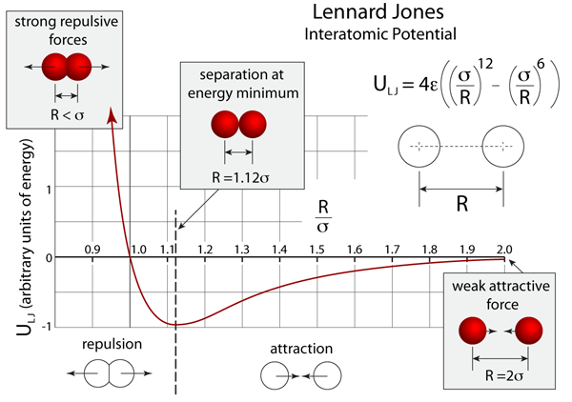
In gasses, the atoms are scattering off one another in all directions, colliding like a game of cosmic pinball. This is what a gas actually is. But, on the other extreme we have solids. In solids, the atoms are all stuck together in a regular lattice of rows and columns, and cannot move around. In liquids however, the atoms are able to move around, sliding past each other, but cannot break free all together. This is what makes something a liquid.
With an intuitive grasp of atoms in motion, it is interesting to look at the characteristics that this motion can take. For example, imagine a cluster of atoms vibrating at a bunch of different frequencies. Such waves in the atomic structure of a material are called sound waves. Sound waves with a high frequency or pitch have a short wavelength, while sound waves with a low frequency and low pitch have long wavelengths.
Heat is also atoms in motion. In fact, it’s the random motion on the scale of the atoms themselves. Therefore, the very highest frequencies of sound are actually modes of vibration that constitute the temperature of an object. In other words, remove all high pitched sounds within the material, including the sound waves with wavelengths on the atomic scale, and the temperature would drop to absolute zero.
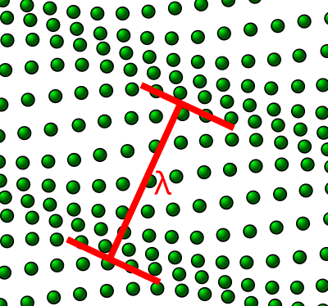
The sound spectrum also continues to the low end with very long wavelengths and very low frequencies. We can also think of vibrating atoms in terms of their period of oscillation. A material object that moves back and forth slowly enough, has wavelengths so long, that they cover the entire object at a macroscopic scale. Since the atoms are moving in unison, its no longer a sound wave, but simply the motion of the object as a whole. Yes, even the atoms in a speeding bullet are moving as it flies.
So, as we can see, motion, sound, and heat, are all just different manifestations of atomic vibrations. However, one might imagine what happens if we include just a feeble touch of self-gravity to our inter-molecular potential. Given by Newton’s laws of motion and universal gravitation, the interplay between gravity on our fluid will have some interesting effects.
On a small scale, gravity is negligible. But as we zoom out, the amount of atoms in our view increases, and the amount of gravity accumulates. Eventually, as we zoom out past the scale of entire worlds, and we can treat each world as a single object, accelerating objects toward it, according to the inverse-square law in 3D space. It’s this self gravity of large enough worlds, that makes them spherical, such as the Earth itself. And it is also the reason the solar system holds together. But don’t even get me started on the complicated dynamics that gave birth to our solar system in the first place.
Take an expanding cloud of gas, with atoms that obey the inter-molecular potential and also Newton’s gravity. The gasses first cool down, and tiny grains form, like a cloud of snow particles. As the cloud fragments, the particles collide and stick, with larger fragments orbiting around one another. Within a relatively short time, you end up with a cosmic web, filled with galaxies that look like spinning pinwheels, and within each galaxy, solar systems containing stars, planets, moons, asteroids and comets, all in orbit around each other. Not bad, because this is exactly what the large scale structure of our actual universe looks like in the first place.

Atoms Two: Abundances of Hydrogen and Helium in the Universe

From this idea, all we need is an empty box, that we fill with a gaseous mix of atoms. But one question arises… What atoms do we use, and by how much? By studying the cosmic abundances of the elements, we can determine that by mass, 75% of the universe is Hydrogen-1, and 25% is Helium-4. Almost. However, there are tiny impurities that makes life possible. Lets take a closer look.
These impurities also are atoms. Bigger atoms. Atoms like Oxygen, Carbon, and Nitrogen, which are essential for the building blocks of life. They and all other atoms only adds up to another 2% of the universe by mass. If the total mass of all atoms is a metric ton, roughly only 20 kilograms of these impurities would be needed.
Lets begin with Oxygen. Oxygen is the 8th element on the periodic table. It is a very reactive and corrosive gas, as it needs 2 more electrons to complete its outer valence shell. Burning Hydrogen and Oxygen together, forms water vapor in an explosive crack. Oxygen also forms diatomic molecules, which constitute 21% of our atmosphere. So, air, water, and even rocks contain lots of oxygen. So lets add 10,420 grams of Oxygen-16 to our box.

Next up is Carbon, Carbon is the 6th element on the periodic table. Commonly seen in soot or charcoal as graphite, it needs 4 electrons to complete its outer shell. Hydrocarbons such as Methane, are what happens when carbon and hydrogen combine. Carbon Dioxide, are what happens when carbon and oxygen combine. In fact carbon can form more molecules and compounds, than all other molecules without carbon combined. Carbon is therefore the next element that is essential for life. Lets now add 4,680 grams of Carbon-12 to our box.
After this, elements get harder to find. In the case of Neon, it is a noble gas, in the sense that neon atoms don’t bond with any other atoms, including themselves. Because its completely non-reactive, means that an atom of neon is a loner. It is the 10th element on the periodic table. Lets include 1,340 grams of Neon-20 to our box.
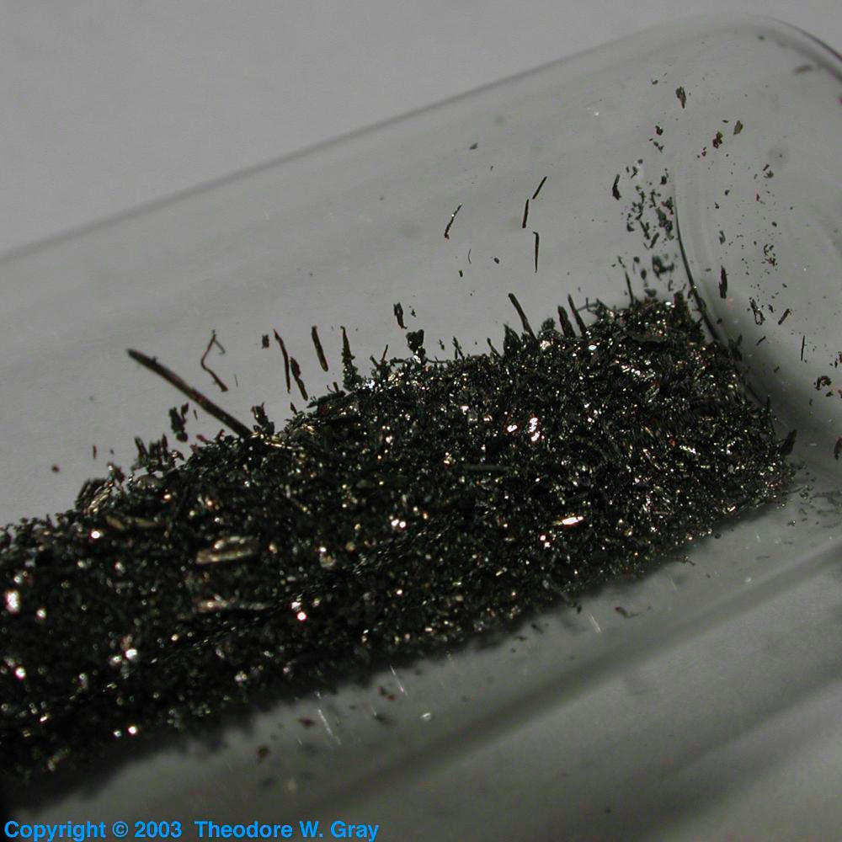
Iron is the 26th element of the periodic table. It is a transition metal. It is a very dense metal, usually likes to lose 2 or 3 electrons depending on the situation, and is found in abundance in the earths outer and inner core. On the surface, it is used as the main component of steel, and therefore modern bridges, ships and skyscrapers will be impossible without it. Lets add 1,090 grams of Iron-56 to our box.
Then there is Nitrogen, Nitrogen is the 7th element on the periodic table. The most natural form is of a diatomic gas, comprising 78% of our atmosphere, with Nitrogen atoms needing 3 electrons to complete their outer shells. In Ammonia, it is achieved by combining with Hydrogen. Nitrates are Nitrogen with Oxygen, and Cyanide is Nitrogen with Carbon. Not exactly pleasant, but is also a key component of amino acids in proteins, some vitamins, and even DNA. Lets thus add our 960 grams of Nitrogen-14 to our box.
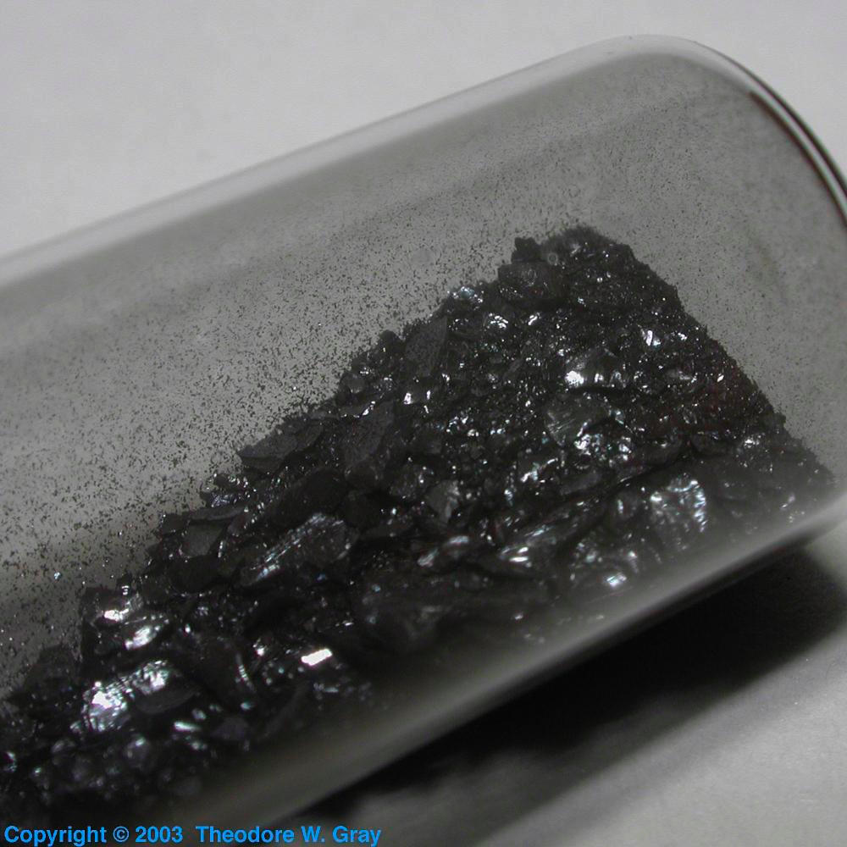
Silicon is the 14th element of the periodic table. It is a semi-metal, which means its properties are between that of a metal and a non-metal. It is this property that makes modern computers possible. Silicon tends to lose 4 electrons to Oxygen, forming a mineral known as Quartz. Glass crystal is just Quartz, and most of the Earth rocks in the Continental Crust are mainly Quartz. Lets add 650 grams of Silicon-28 to our box.
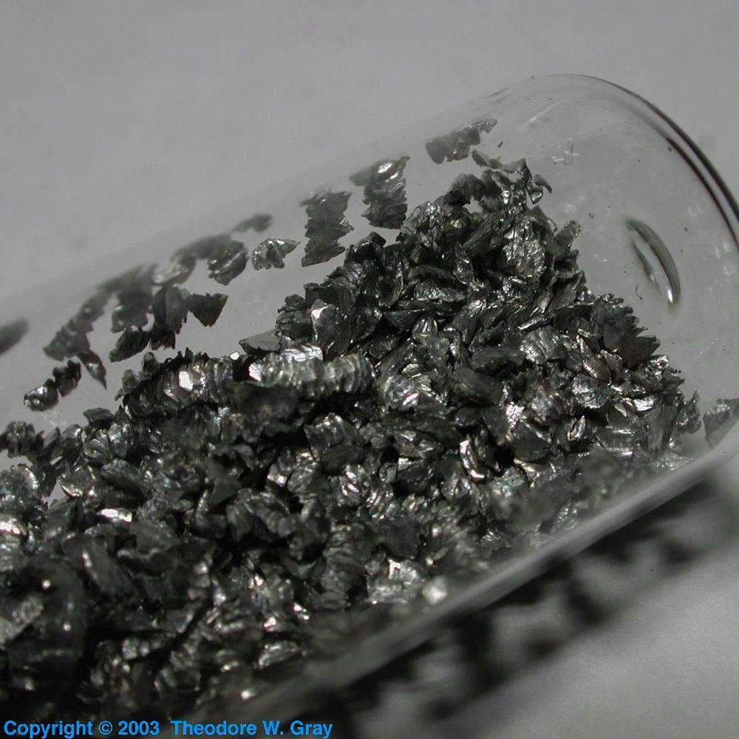
Magnesium is the 12th element of the periodic table. It is an alkaline earth metal. From its name, Magnesium tends to lose 2 electrons to Oxygen, and when combining with quartz minerals, forms a mineral known as Olivine, a green jewel that is a key component of most of the Earth’s mass in its Mantle, even including some Oceanic crust. Lets add 580 grams of Magnesium-24 to our box.
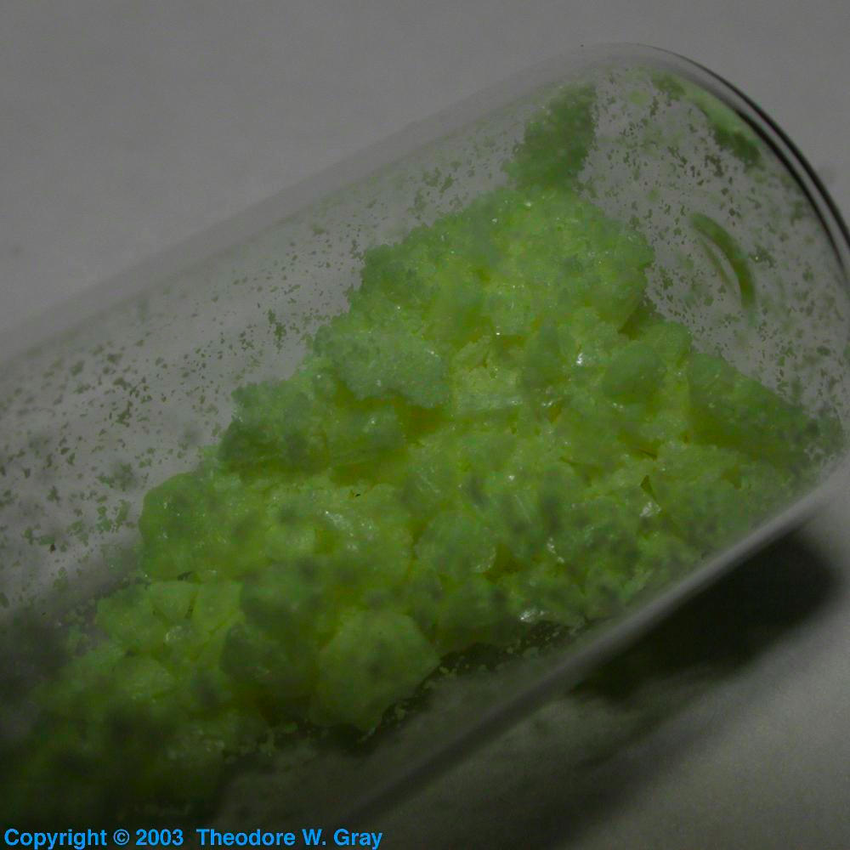
Second to last is the stinkiest element, Sulfur. Sulfur is the 16th element of the periodic table. Some common forms of sulfur include hydrogen-sulfide, the gas with the characteristic rotten egg smell, and sulfuric acid which is found in car batteries, and is extremely corrosive. Sulfur combines with other elements in our bodies in many proteins, and a few vitamins. Lets add 440 grams of Sulfur-32 to our box.
Lastly, we have Argon. Like Neon, and Helium before it, it is a noble gas, comes as single atoms, and is completely inert and non reactive. It is the 18th element of the periodic table. Lets finish by adding 200 grams of Argon-36 to our box.
So in short, many of these elements make like possible. With a universe as large as ours, it would be quite strange if earth life is the only life out there. With Oxygen, Carbon, and Nitrogen, in the mix from the get go, alien life should be inevitable. But this is the last 2% of all atoms by mass. Hydrogen and Helium make the atomic majority.
Hydrogen-1 makes 75% of our metric ton box, and Helium-4 makes 25% of our metric ton box. Hydrogen-2 and Helium-3, although stable, are quite rare in terms of mass, but by number, 26.4 ppm is Hydrogen-2 and 10.3 ppm is Helium-3. Also by number this means that we have 750,000 ppm of Hydrogen-1, and 62,500 ppm of Helium-4. Hydrogen tends to form diatomic molecules, and Helium being a noble gas is an inert gas of single atoms. Hydrogen is the 1st element of the periodic table, and Helium is the 2nd element of the periodic table.
But! That is not all there is, and far from it. In fact, remember that all material things are atoms, but that isn’t to say that other forms of energy exist out there that are not atoms. You might be surprised to know that 5 metric tons of microscopic black holes have to be added to the box, in order to match cosmological observations. These black holes are essentially invisible and intangible, just like a ghost. This is because the invisible matter that holds galaxies together into the cosmic web, interacts only through gravity. As we know already, a rotating black hole is a particle with mass and spin, just like an electron in an atom or photon of light. In other words, the fleeting existence of quarks and gluons inside the atomic nuclei we discussed are also microscopic black holes. Everything is black holes! It’s just that the black holes in atomic matter have properties with such small mass, that they act more like ripples in fields, but nonetheless, the invisible matter that holds the galaxies of the cosmic web together is real.

Atoms Three: Atomic Structures and Substructures

As it turns out, every atom of the periodic table consists of a heavy and dense, positively charged nucleus, surrounded by two fields, the electronic field and the optic field. The discrete vibrations of the electronic field are the negatively charged low-mass electrons in atoms, while the discrete vibrations of the optic field are the photons of light, which carry the electric and magnetic forces from one place and time to another. Put together, electrons and photons create all of the solid state and chemical forces within any substance.
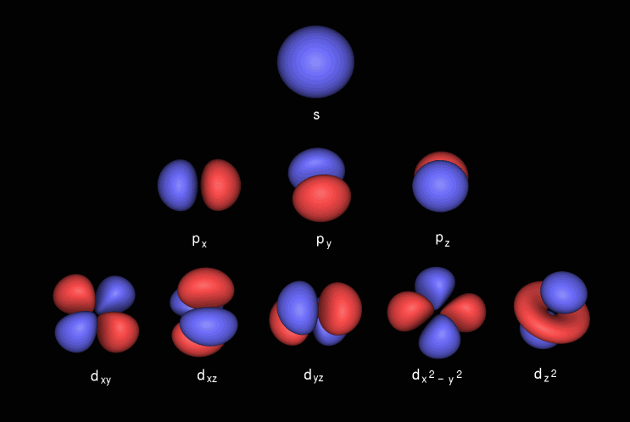
Within an atom, the electrons fill “shells” or orbitals two electrons at a time. Each of these orbitals is a standing wave of the electronic field. Since the nucleus is heavy and positively charged, it creates a sink for electrons to be attracted to. The reason why electrons fill one orbital at a time is because they are anti-symmetric under exchange. This is what makes an electron a particle of matter. For comparison, photons of light carry the electric and magnetic forces, because they are symmetric under exchange. Ultimately the reason why electrons are anti-symmetric, rather than symmetric, is tied to the fact that the electronic field itself only transforms half as much as the optic field does under a change in spacetime perspective. But enough about electrons and photons, what is the atomic nucleus anyways? After all, if electrons and photons were all there is, there would be only a single type of atom: Positronium and nothing else, and even then, given that Positronium atoms annihilate by themselves in less than a billionth of a second, what gives?
The answer lies in the fact that there are roughly 250 stable nuclei, and thousands more unstable nuclei. Once we zoom inside the nucleus, we understand that it is a chaos of nucleons and pions. It is said that nucleons are quark triplets, and pions are quark-antiquark pairs. But, in reality, the nucleus is a swarm of quarks and gluons, that are discrete waves in their respective fields, that only resonate fully as composite units. There is much to know as of yet about the field equations, such as their non linear behaviors, which are important to the structure and function of various nuclei, such as properties like radioactivity and binding energies. But all of the nuclei would not exist, without a chain of events of the early universe, known as the big bang.

The Book Of The Cosmos

Cosmos One: The Universe Goes Bang!

Before the beginning, there was absolutely nothing: No space, no time, no matter. And from nothing emerges everything. Thus, in the beginning, everything is an infinitely dense, infinitely hot, singular point of origins. This mysterious point, is what created everything that follows it, and obeys a set of rules known as the laws of physics. The theory of everything is also known as the unified field theory, because that is what reality is made of: Waves! But for now, lets turn our attention to the following sequence of events…
In the first tiniest fraction of an instant, the universe explodes into existence, as a rapidly expanding, tremendously hot and dense firestorm, spread uniformly across space, and that extends infinitely in all directions. It is like dropping a nuke in every cubic micron of space, but then to realize that your cubic micron is now a cubic kilometer, as space itself, ever more slowly, continues to expand out in all directions. The universe continues to expand and cool.
In just another few tiny fractions of an instant or so, the tremendously hot and dense, but uniformly spread firestorm that is infinite in extent, has expanded, cooled, and diluted, into a not so hot, not so dense firestorm, that continues to be uniformly spread, and infinite in extent. For some actual numbers, given that our “not so hot” universe, now means ten quadrillion degrees, imagine how incomprehensibly hot the universe was right at the start: ten quadrillion times hotter than ten quadrillion degrees! The universe continues to expand and cool.
So. With this in mind, lets now track the evolution of our particles. Every particle in existence, is constantly smashing into other particles. We say that the particles are in thermal equilibrium. The average kinetic energy per particle, is uniform throughout the cosmos. Looking at the sound waves within the aether, we can see the waves are vibrating with an extremely high frequency. We will measure frequency with a new system of units. The electron volt. Its written as, “eV”. Electron volts are useful because they can be understood as, energies, momenta, frequencies, and wavenumbers. In quantum field theory, everything is measured in electron volts. Light speed is 1 foot per nanosecond, and one electron volt of energy corresponds to a wavelength of 1.24 microns. As of now, the weak interaction and the electromagnetic interaction, are one and the same. Moreover, every particle is massless, and moves at the speed of light. This will change soon, when the temperature drops below 246 GeV. The universe continues to expand and cool.
Passing 1 femtosecond, all of the quarks, antiquarks, leptons, antileptons, and the bosons, are almost in thermal equilibrium, and haven’t yet aquired mass from this so called higgs boson. Yet after 10 picoseconds, the temperature drops below the threshold of 246 GeV, and the higgs boson activates. The electromagnetic force carried by photons, is now distinct from the weak nuclear force, carried by the W plus, W minus, and Z bosons. These intermediate vector bosons, along with the higgs boson itself become very massive, on the order of 80 GeV, 92 GeV, and 125 GeV respectively. Since the electroweak bosons interact between themselves, we would expect to find confined states of these bosons. However, now that some of these electroweak bosons have a great deal of mass, removes any possibility of confinement. However these are not the only massive particles around. Every flavor of quark now has three possible masses. There are the up, charmed, and top flavors, and then the down, strange, and bottom flavors. The same applies to the charged leptons, which are the electron, the muon, and the tau. The neutral leptons, the neutrinos, do not have mass, and as such continue to move at light speed. The three top quarks, which are the heaviest flavor of the up type quarks, have masses of 173 GeV. That is much heavier than the W, Z, and the higgs boson. The universe continues to expand and cool.
After the next few hundred picoseconds, the top quarks and antiquarks, higgs bosons, Z bosons, and the W plus and minus bosons, are all gone. The energy of their annhililation, gets dumped into the remaining lighter particles. With these particles out of the picture, the weak interaction, reemerges as a short ranged force, 100 times shorter than a femtometer. In contrast, the quarks and gluons, are starting to feel their presence. This is why we call this the strong nuclear force. This force has litterally several metric tons of strength. The universe continues to expand and cool.
As we pass the ten nanosecond mark, the 4.5 GeV bottom quarks, 1.7 GeV tau leptons, and the 1.2 GeV charm quarks, annhililate away next. This seems like a losing battle, as all of the precious universe building particles, are just dissapearing, one by one, until nothing is left. After all of this, the only massive particles left are, the strange quarks, muons, down quarks, up quarks, and electrons, along with their antiparticles. So, to summarize. In these first instants, all sorts of exotic forms of energy and matter existed, such as quark matter, strange matter, and even antimatter, existed in great abundance. The universe continues to expand and cool.

Cosmos Two: The Quarks Held Hostage!

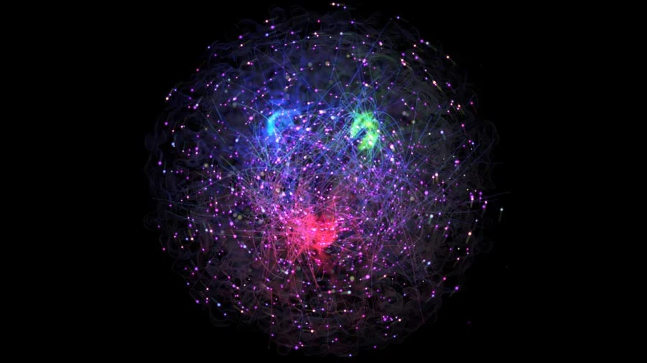
Then, all of a sudden, right after 30 microseconds, the quarks and antiquarks bind together, into subatomic particles known as hadrons. Hadrons made of three matter quarks are known as baryons, and hadrons made of a quark antiquark pair are known as mesons. The lightest baryons are the nucleons, which have a mass of 940 MeV. The lightest mesons are the pions, which have a mass of 135 MeV. However the up quarks with masses of 2.01 MeV, and the down quarks with masses of 4.79 MeV, that make up these subatomic particles only contribute 1% of the total mass of the hadron. Strange quarks are the only exception to this rule, as they have a mass of approximately 95 MeV. These hadrons are confined, as it is impossible to remove any quarks or gluons for that matter, without creating other hadrons in the process. The fundamental strong nuclear force only acts within one of these subatomic particles, because of this confinement. This confinement is caused by the taffy life gluon flux tubes that emerge from the center of the hadron, and stretch out to the locations of the quarks. Again this is caused by the self interaction of the 8 types of gluons. Most hadrons have a physical size of around 1 femtometer. This is 100 times larger than the weak force can carry. In terms of electron volts, this corresponds to a value of 197 MeV. The temperature is dropping below 200 MeV. The universe continues to expand and cool.
Over the course of a few dozen microseconds after the quark gluon plasma transitions to a baryon meson gas, the resulting subatomic particles are much to heavy to exist, and as such they annhililate away. The small excess of matter quarks over antimatter quarks that are left behind, is now in the form of nucleons, which are the protons and neutrons. This is the very first real tangible matter in the universe. A proton is made of 2 up quarks and 1 down quark, and a neutron is made of 2 down quarks and 1 up quark. Yet these nucleons are outnumbered in the billions by the rediculous numbers of pions, that are being copiously produced in the seething 150 MeV heat. But what is important here is that as all kinds of quarks and all kinds of antimatter quarks, warred for supremacy, emerged a thin excess of protons and neutrons: The particles of matter we know today. The universe continues to expand and cool.
Yet the temperature not going to be this hot for long. So as the temperature drops below 135 MeV, pions begin to decay. The pions being made of quark antiquark pairs are very unstable. The charged pions are made of one up quark, and one anti down quark, or vise versa, and thus take a couple dozen nanoseconds to decay. The neutral pions on the other hand, are made of a quark antiquark pair of the same quark flavor, and so annhililate almost immidiately. Muons which weigh around 105 MeV, go next, after a couple microseconds. The universe continues to expand and cool.
And finally we reach the 100 microsecond mark in the history of the universe. If we were to take a census of all the particles in the universe as of now, there are 52.5 billion neutrinos, 20 billion photons, 17.5 billion electrons, 17.5 billion positrons, and finally 8 protons and 8 neutrons. There is also an excess of 8 electrons, that meet the requirement of the universe being electrically neutral. Like the W and Z bosons, the charged and neutral pions, act as short ranged force carriers. Since the pions are hundreds of times lighter than the electroweak bosons, they carry the residual nuclear force out to a 2.5 femtometers of distance, which is around three nucleons wide. However, it is still way too hot for the first nuclei to form. Yet. The universe continues to expand and cool.
But going back to a fraction of a thousandth of a second since the beginning, for every proton or neutron created in this cosmic game of pinball, billions of photons, of gamma-ray light, were also created! The universe was dominated by energy, and yet again, what I referred to as a thin excess will amount to all of the matter in our universe that will ever exist! Along with the billions of gamma rays, there also exist billions of electrons and antimatter electrons, also known as positrons. The temperature is still too high for electron-positron pairs to begin annihilating, and they remain in flux. The universe continues to expand and cool.
Now we reach the 1 millisecond mark. The temperature is in the tens of MeV. Electrons and positrons also known as antielectrons, even the sea of photons and neutrinos, continue to bash into the few isolated protons and neutrons, turning them into one another. This happens due to the weak nuclear force that acts at a scale 100 times smaller than a proton or neutron. When an electron gets near a up quark inside a proton, of which the quark has a electric charge of +2/3. If it is close enough, the up quark will transmute into a down quark, with a charge of -1/3. The proton has turned into a neutron. If this neutron hits a positron, it will convert back into a proton. The massless neutrinos, that act exclusively with the short ranged weak force, also have the ability to convert protons and neutrons into eachother. So at this point in time, protons and neutrons are always converting back and forth. So at first, the firestorm of mostly gamma radiation and electron-positron pairs, contains an equal number of protons and neutrons. The universe continues to expand and cool.
However the neutron is only 780 keV heavier than a proton, and the electrons weigh in at a tiny 511 keV. So as the temperature drops to a few MeV, it becomes much easier to make protons than to make neutrons in these conversions, and so there are fewer and fewer neutrons around as compared to protons. Over the next second or so, electrons and positrons are also starting to go through the same annihilation, that the quarks went through right at the start of creation. Then, as we pass the 1.8 second mark, the electron positron pairs begin annhililating, and over the next few hours, the concept of antimatter will become a distant memory. The universe continues to expand and cool.
Also around this time, the neutrinos have not annhililated with their antineutrinos, because of their massless nature. Yet, as the universe continues expanding as it always does, the neutrinos and antineutrinos are having great difficulty turning protons and neutrons into one another. This is because of the extremely short range of the weak force. When this process begins, the ratio of number of neutrons to number of protons, was dropping dramatically for a few seconds. The universe continues to expand and cool.
So now that neutrinos cannot change the number of protons or neutrons, the declining neutron number then settles at a value of 3 neutrons per 13 protons. Yet, neutrons are ever so slightly heavier than protons, and should decay. As of now the lifetime of a neutron is around 880 seconds, which is too far into the future as of now. The universe continues to expand and cool.

Cosmos Three: Lets Go Nuclear!

One second passes, then five, then 20 seconds have elapsed. Then a minute passes. The residual nuclear force, is strong enough to bind the nucleons together, but this isn’t happening at all. This is because when a proton and neutron collide and form a deuteron, a high energy photon will break the first nuclei right back down to the nucleons that already exist. But a deuteron has a binding energy of 2 MeV, so it should be stable enough to exist. Nope. Remember that there exist 20 billion photons. Even if the average temperature of this thermal radiation is on the order of 100 keV, or 0.1 MeV, there will still be a few outliers with energies over 2 MeV. Even if a few very high energy photons exist, its over for a deuteron. The universe continues to expand and cool.
Yet again, as always, the universe expands and cools. Also, neutrons decay, so given that we started with 3 neutrons at first, after 3 minutes, there are only 2 neutrons left, as one of the neutrons has beta decayed back to a proton, along with an electron and an antineutrino. We now have 20 billion gamma ray photons, along with 14 protons and 2 neutrons. Also, an excess of 14 electrons also exist, along with the hundreds of millions of electron-positron pairs that are under constant annhililation. The universe continues to expand and cool.
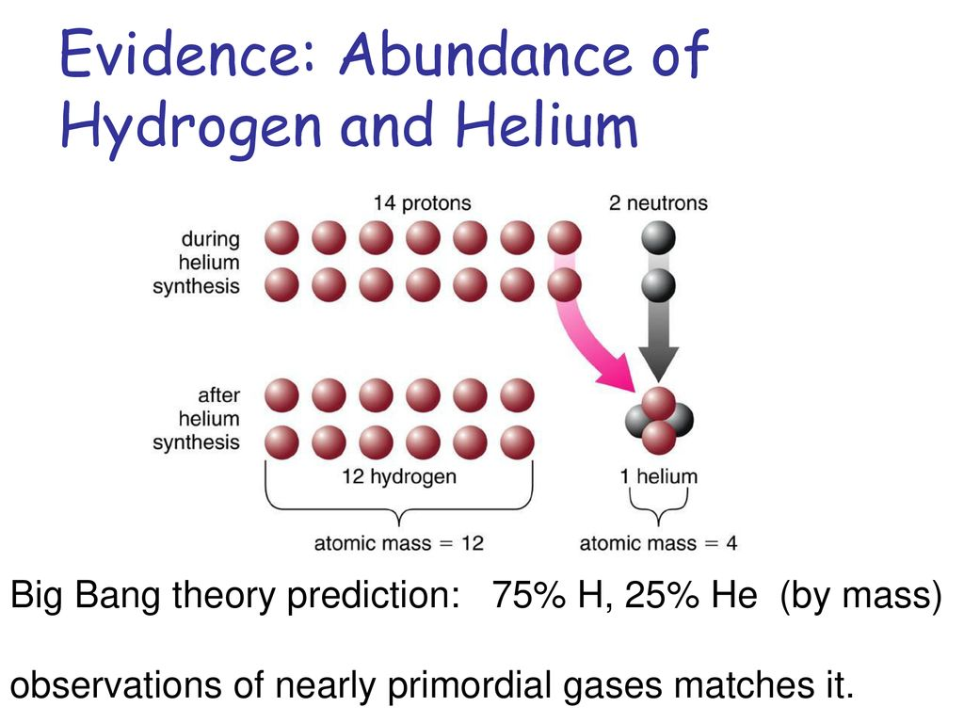
So this means that for the next four minutes or so, not much changes to the firestorm of gamma-rays and annihilating electron-positron pairs. A few of the many neutrons that still exist, have naturally decayed back into protons, so while the neutron to proton ratio used to be 1 in 5 a few minutes ago, right now its closer to 1 in 7. I should note that although the temperature is well high enough for fusion to occur, the sheer energy and number of gamma ray photons will shred down any nuclei that try to form, so the universe, as of now, contains only free protons and free neutrons. The universe continues to expand and cool.
Then, right after the clock strikes 4 minutes and 20 seconds, does something dramatic happen: Nuclear fusion! Now, as the temperature decreases, there are less and less photons with energies of 2 MeV, and when the temperature, or average photon energy, drops below 78 keV, deuterons are stable, and the fusion process continues on. In other words, the intensity of gamma radiation is now low enough for the first nuclei to not be blown apart. Most nuclei that could form at this point, like tritons or helions, also have binding energies not much more than deuterons. However there is one special kind of nucleus, known as a alpha particle. It has a whopping binding energy of 28.3 MeV. That is to say 28,300 keV! The universe continues to expand and cool.
It consists of two protons and two neutrons. The stability of alpha particles, is extremely important in the near future of the nuclear reactions. Every proton and every neutron in existence are now smashing together to build alpha particles: Clusters of 2 and 2, that is to say, 2 neutrons with 2 protons. The universe is now 265 seconds, or 4 minutes and 25 seconds old. At this point, as soon as alpha particles form, it becomes extremely difficult to destroy them. All nuclei that contain any neutrons, including the soon to decay neutrons themselves eventually get locked up inside these alpha particles. The universe continues to expand and cool.
For the next 10 seconds, the number of alpha particles, grows to a value of 1 alpha particle for every 12 protons. The story of alpha particles, is not over yet. As the clock reaches 4 minutes and 30 seconds, all of the neutrons get used up in the reaction, and the 10 seconds of nuclear fusion grinds to an immediate halt. Why so early? Even though fusion is still occurring in vast quantities, not much happens to the composition of the nuclei. The 12 protons, and 1 alpha particle, are all smashing into one another. When such a collision takes place, it produces an unstable nucleus with 5 or 8 nucleons. Such a nucleus will undergo alpha decay, and revert right back to the same nuclei as before. The universe continues to expand and cool.
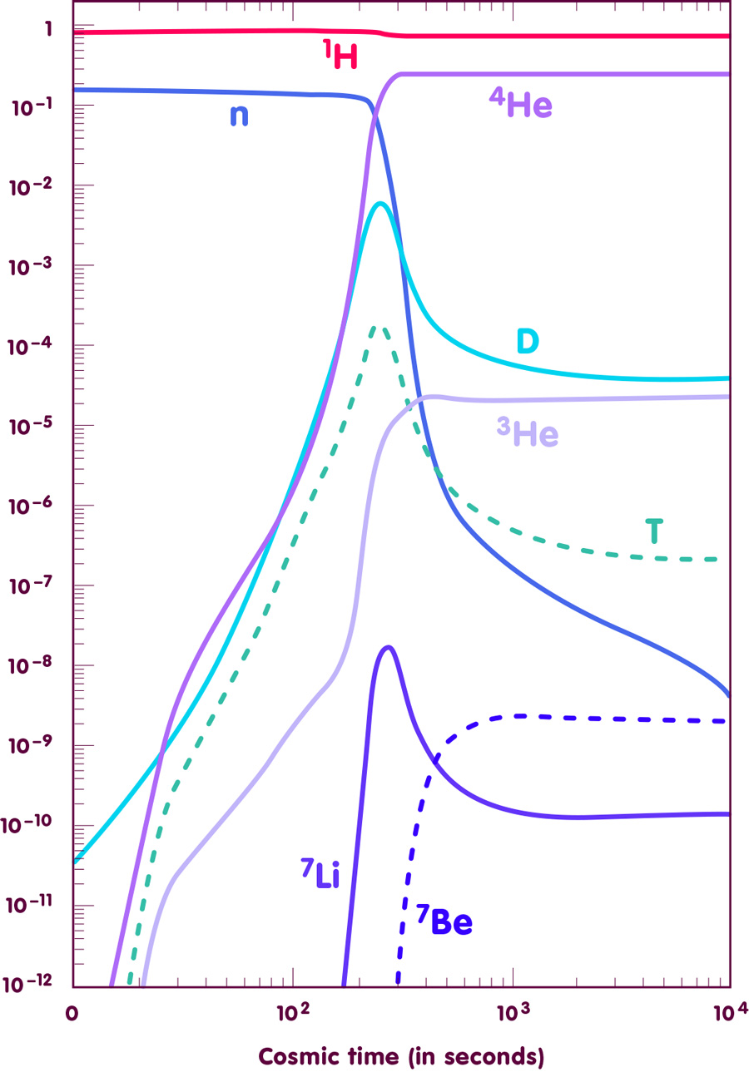
After some more time for the universe to expand and cool, the universe ages past the 20 minute mark. However, these stable nuclei are positively charged, and like charges repel. This means that there is an electric potential barrier right beyond the reach of the residual nuclear force. As the nuclei slow down, there is less and less kinetic energy available, and by the end of the first hour of the universe, almost every nucleus avoids every other nucleus around it. The ever expanding and cooling universe now has a chemical formula of 12 protons, 1 alpha particle, which goes along with an excess of 14 electrons over millions of electron-positron pairs, and also the 25 billion photons of gamma-ray light. The universe continues to expand and cool. The fusion process halts completely, as the 12 protons, and 1 alpha particle, not only fail to create new nuclei, but at this point they don’t touch eachother in the first place. The nuclei just avoid eachother from now on. The universe continues to expand and cool.
Hours into the creation of the universe, the last few dozen electron-positron pairs finally annihilate away into even more photons of gamma-ray light. The particle count is now, 12 protons, 1 alpha particle, 14 electrons, and 26 billion photons. This it will remain for almost an eternity. As a sense of comparison, a proton weighs as much as 1,836 electrons, and an alpha particle weighs as much as 7,294 electrons. The universe continues to expand and cool.

Cosmos Four: Let There Be Light!

This whole time, electrons and photons, pinball one another. The scattering of, electrons and photons, is fully described by the theory of QED. QED begins with the spacetime of special relativity. This spacetime is described by the O(3,1) group. The particles of QED, are representations of this symmetry group. Electrons are massive charged spinors. Photons are massless neutral vectors. Put together, they interact via a minimally coupled U(1) internal symmetry group. As of now, QED was not the main player in the history of the universe, as it was unified with other internal symmetries, into the SU(5) group. The universe continues to expand and cool.
However, now that the nuclear reactions have stopped, QED is what is left over. The electrons and photons form a plasma known as the cosmic soup. In it, electrons are known as cathode rays, and photons are known as X rays. The chemistry of the universe is pretty much constant after the first few hours have elapsed. The cosmic soup clocks in at a temperature of 1 keV. Otherwise put, 11.6 million degrees kelvin, and dropping. In fact, it’s still too hot for anything tangible to exist at all. The universe continues to expand and cool.
A day passes, then a week goes on by. The only thing that changes is the expansion of the universe. Nothing has happened to the plasma. Even after a whole month of this expanding and cooling, the temperature, pressure, and density, are all surely dropping, yet nothing else has happened to the cosmic soup. Why? As compared to the nuclei, which are femtometers in size, and weigh in at many GeV, electrons are nothing in comparison. Even the photons that carry the electromagnetic force, is 137 times weaker than the other forces. So not only do the electrons need to slow down, they need to be captured by the nuclei, for the first atoms to form. The universe continues to expand and cool.
Every electron, cannot be crammed into a volume smaller than 386 femtometers, without producing antimatter. This is assumming that the cathode rays are moving near light speed. But, at this day and age, the cathode rays have much longer wavelengths than this, since they’re moving much slower than light speed. The math of QED, says that the electrons must be moving 137 times slower than light speed for them to be captured. With the electrons so spread out compared to the nuclei already, the cathode rays must have wavelengths hundreds of thousands of times longer than the nuclei are big. And that is a big problem. The universe continues to expand and cool.
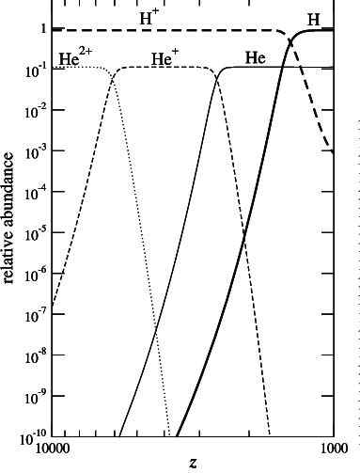
As months turn into years, then into decades, the gamma ray photons have stretched out so much, they are now X-ray photons. As the firestorm of a universe continues to expand and cool, not much happens for a very long time. The universe as a firestorm that is uniformly spread and infinite in extent, continues to expand and cool. Decades pass by, then centuries, and eventually millennia pass by in the hundreds. The universe is so much more diluted now that its self gravity, which is slowing down the expansion of the universe, takes more time to expand by the same amount as usual. Moreover, all of the photons of X-ray light, have stretched out into photons of Ultraviolet light. The universe continues to expand and cool.
Moreover, as the universe expands, a new problem surfaces. Billions of photons might have an average energy of 5 eV or 58 thousand degrees kelvin, yet the truth is that as always there are high energy outliers. Some photons have huge energies well over 269.3 eV and as such we will have to wait until these high energy photons are gone until atoms can fully form. The universe continues to expand and cool.
As the universe expands and cools below 16 thousand degrees, each and every alpha particle captures an electron forming helium ions. Next, as the universe expands and cools below 7 thousand degrees, each and every helium ion captures another electron, this time forming helium atoms. Then, as the universe expands and cools below 4 thousand degrees, each and every proton captures an electron, forming hydrogen atoms. After that, as the universe expands and cools below 3 thousand degrees, the electrons clear up, leaving the now visible light photons to begin streaming freely throughout the cosmos. Let There Be Light!

Cosmos Five: Trouble Brewing In The Cosmic Darkness!

The universe continues to expand and cool. 377 millennia have elapsed since the beginning, and is flooded with atomic hydrogen and helium. The color temperature of the radiation is pushing 3 thousand degrees Kelvin, but is gradually dropping as we speak.
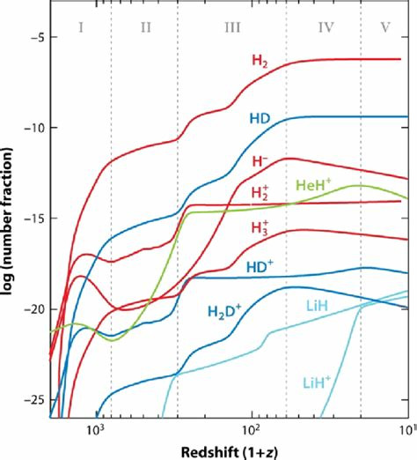
So far, we have been talking about only a small fraction of what matter and energy exists out there. It is like saying we have a jar filled with 100 grams of gas. As we know from earlier, 75 grams would be atomic hydrogen-1, and 25 grams would be atomic helium-4. The truth that has been overlooked is this conundrum: An additional 530 grams of invisible intangible matter also exists.
This form of matter consists of countless microscopic black holes. A black hole is a region of space with a gravitational pull that is so strong that not even light, the fastest thing in the universe, cannot escape from its deadly grip. In physics, we know a few things:

1). Universal Gravitation: All particles attract all other particles, with an inverse square force field, in three dimensional space. This is why all objects fall to the ground at the same rate, why the planets move around the sun in ellipses with the sun at one focus and the other focus empty, and why a line drawn from the sun to a planet sweeps out equal areas in equal time intervals, and also explains why the semi major axis of a planet’s orbit cubed is proportional to the orbital period squared, along with many other gravitational effects. It is the gravitational acceleration of space itself, sourced by a particle, that spreads out according to an inverse square law in 3D space. This is what keeps your feet on the ground, and the earth orbiting the sun.
2). Special Relativity: The dimensions of space and time, arrange themselves such that the speed of light is the same, from all moving perspectives. This means that among many new phenomena, fast moving clocks run slow, fast moving rulers contract along their direction of motion, high speed motion breaks the simultaneous nature of time, and most importantly nothing moves faster than the speed of light. The fact that the speed of light moves at the same fixed speed no matter how its source is moving, means that the dimension of time rotates in an opposite way, than the three other dimensions of space rotate.
3). Quantum Mechanics: Every wave can be thought of as a stream of particles. The total kinetic energy of such a particle is directly proportional to its corresponding probability wave frequency. Moreover, waves with shorter wavelengths correspond to identical particles with more momentum, that is to say, the product of mass and velocity. This leads to the notion that objects can be in more than two places at once, how particles and waves are actually the same thing, how these quantum waves have discrete harmonics like the specific notes on a musical intrument, and the weird notion that measuring one particle can reveal corelations in the properties of all other particles of the same type.

This is an extremely important concept: All fundamental particles are rotating black holes with the same mass and same spin as the wave they constitute. This means that all black holes are fundamental waves too in the same sense as of any other wave, such as the electrons of electricity and the photons of light are all fundamental waves. This means that we should widen our search for extremely exotic wave types that hardly interact with anything. These microscopic black holes will be a fundamental turning point in the evolution of what follows.
The fate of the universe rests on the unification of physical law. There are three main sets of new phenomena, that were incorporated into the three pillars of modern science. The three pillars are: universal gravitation, special relativity, and quantum mechanics. The associated physics reduces to our common sense, by making a series of approximations. So even though our common sense worldview works well in the everyday, in the grand scheme of things, our universe is stranger than fiction.
With this in mind, a black hole is simply a natural consequence of these three main concepts of physics. In a sense, every black hole is just as fundamental as every other particle of matter and light that exists. In fact, the only difference is their mass and spin. Therefore, all rotating black holes are just as “real” as anything else that exists. Lets see what has happened to this mysterious form of matter, so that we can continue our story of everything!
All of these black holes have been colliding and merging, since the beginning, forming a sprawling network of black holes, called the cosmic web. The cosmic web is truly massive. But the reason I bring this up is because, before now, the radiation pressure was holding up the ordinary matter from gravitational collapse. But now, the light has been set free, there is no more radiation pressure to prevent collapse, and collapse it goes.
As the universe expands and cools, over the next few million years, the color temperature drops from white, to pale yellow, to vivid orange, to cherry red, and finally fades into the near infrared. If we were somehow around back then, we could feel these rays as radiant heat, although there would be nothing to see. Just a uniform still darkness all around.
As for the matter, the gas is no longer uniform, and as the contrast increases, the gravity of both the black holes and the atoms of hydrogen and helium, becomes unstoppable. In just a few hundred million years, the cosmic web of gas starts resembling the cosmic web of black holes. This is like the scaffolding of a building. The black holes are the scaffolding, and the gas of normal matter is following the same pattern.
As this new consolidated cosmic web continues to expand and grow, the scene will soon change dramatically to include new structures never seen before! The cosmos is still cold and darkness envelops the night sky. But a chain of events will form a hierarchy of scale, where everything will eventually depend on everything else.

Cosmos Six: Cosmic Evolution Of Stars And Galaxies!

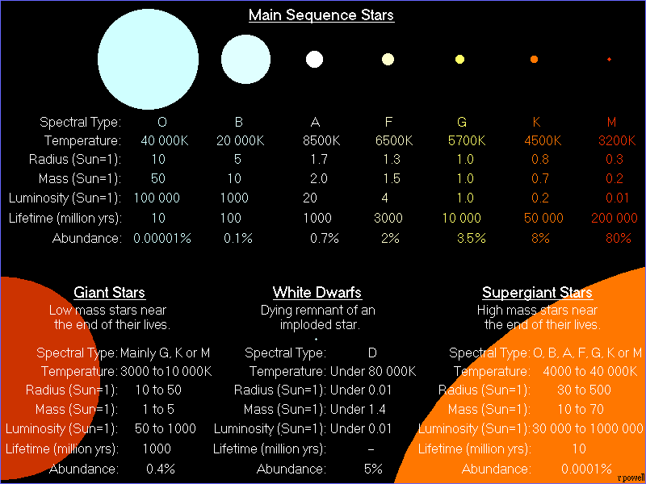
As the cosmic web continues to expand and grow, the first irregular galaxies form along the filaments of the cosmic web. Just like dew drops on a spider’s silk, each of these galaxies is a loose collection of stars, gas, dust. As time marches on in the billions of years, the irregular galaxies merge into larger irregular galaxies. As it turns out, the densest regions of the cosmic web are where the irregular galaxies form. But since the cosmic web grows, the galaxies are carried along with the filaments of the invisible matter that consitutes most of the cosmic web. Whenever the filaments of the cosmic web lock together, is when most galaxies cluster and merge.
Zooming inside one of these irregular galaxies, there is plenty of gas from the big bang, and along with the dust from previous supernovae explosions, creates a cloud of diffuse gas known as nebula. The nebula fragments into a few collapsing clouds, which in turn forms the next generation of high mass stars: Blue main sequence stars. 10 solar masses, and their surfaces burn brightly as 20 thousand degrees in the ultraviolet, as a sky blue color. The nuclear fusion has restarted once again, this time within the cores of stars!
After another brief 100 million years later, the blue main sequence star, runs out of its initial supply of nuclear fuel. It expands from a radius of 5 suns to 530 suns. Its surface temperature drops to 4000 degrees, or about that color of incandescent white light bulb. It is now an orange supergiant star, with its core temperature skyrocketing, inside, it has onion shells of fusing elements and isotopes. It lasts for only another 10 million years.
Every massive orange supergiant star explodes as a type II supernova! This star is no exception. The core has fused its last supply of elements into Iron-56, the most stable nucleus that exists. The core implodes in fractions of a second, into a neutron star remnant. The resulting conversion of nuclei into pure neutrons relases plenty of energy, that ricochets the rest of the stellar matter, creating a massive shockwave that blows it up. The energy from such an explosion outshines the rest of its galaxy for weeks, if not months. The explosion leaves behind a neutron star, which is a dead stellar core of compact neutron matter.
The resulting elements from type II supernovae contains: 23 carbon-12 nuclei, 5 nitrogen-14 nuclei, 156 oxygen-16 nuclei, 14 neon-20 nuclei, 2 neon-22 nuclei, 6 magnesium-24 nuclei, 4 silicon-28 nuclei, 2 sulfur-32 nuclei, and 2 iron-56 nuclei. Massive star explosion, after massive star explosion, the galaxies are being seeded with the elements needed for life itself. Elements like oxygen, which when combined with hydrogen from the big bang, forms lots and lots of water, the universal solvent. The gases and dust grains disperse into the interstellar medium.
A neutron star remnant is a very amazing object. A dense quantum object made of a plasma of only neutrons. However the neutrons are as compact as they can be. This is the same force that prevents solid matter from passing through itself, but here, it applies to the whole neutron star remnant at once: An atomic nucleus as massive as a star. For some facts, a neutron star remnant, has the mass of up to 3 suns, and a radius of a large city.
We zoom back out to the intergalactic scale. A few billion years have elapsed since the first irregular galaxies formed. As the invisible matter of the cosmic web locks together, two sheets of this invisible matter, with each sheet being a network containing more than a few dozen irregular galaxies, merge together. What was two galaxy clusters is now a grouping of a few larger galactic mergers. Gas, stars, dust, are all flung in all directions. Gravity brings the matter back together into three large spiral disk galaxies, which in turn ignites more stars within these new spiral galaxies. This creates their spiral arms and pinwheel character. In the mean time, the invisible cosmic web has grown so much by now, that what was a network of irregular galaxies is now three huge hubs of the invisible matter, inside each a spiral galaxy. It is as if a cosmic dance is taking place, with the skaters replaced by huge incandescent galaxies. The three new spiral galaxies continue to absorb more and more irregular galaxies into their spiral arms. This slightly disrupts their spiral arms, but after another few billion years, each of these spiral galaxies has grown considerably, now as three grand pinwheels.
Zooming inside one of these spiral galaxies, there is still lots of gas from the big bang, and along with even more of the dust from previous supernovae explosions, which creates several more clouds of diffuse gases that we know as nebulae. These nebulae fragment more, and due to extra turbulence from supernova explosions in nearby spiral arms, they collapse and fragment further into a few hundred collapsing clouds, which in turn forms the next generation of intermediate mass stars. One of these stars is the sun! 4.6 billion years ago! Our sun and all the others in the loosely bound cluster, known as an open star cluster, burn with a surface temperature of 6 thousand degrees, which looks more or less, like white daylight. The open star cluster disapates its sun-like stars into the disk of the spiral galaxy that birthed them. Nuclear fusion has it’s torch passed down to the next generation of stars!
10 billion years later, the sun expands to 60 times its original radius. This red giant star, and has a surface temperature of 3000 degrees, about that color of an older incandescent light bulb. The sun’s core has begun to fuse its helium-4 ash into carbon-12 and oxygen-16. This bloated angry red giant star, lasts for another 1 billion years, until it’s core becomes dangerously unstable. The core gets denser and energy waves from it, expelling plenty of stellar matter away from the diffusing red giant star into what is known as a planetary nebula. After a few thousand years later, what is left over is a very dense dead stellar core of compact atomic matter known as a white dwarf.
The resulting planetary nebula contains: 69 carbon-12 nuclei, and 12 nitrogen-14 nuclei. Like the other supernovae explosions, the planetary nebulae from countless red giant stars seed the galaxies with even more matter, necessary for life, which includes a plenty surplus of carbon. The gases and dust grains disperse into the interstellar medium.
A white dwarf remnant is a quite amazing object. A dense quantum object made of a plasma of nuclei and electrons. However the electrons are as compact as they can be. This is the same force that prevents solid matter from passing through itself, but here, it applies to the whole white dwarf remnant at once: An atom as massive as a star. For some facts, a white dwarf remnant, has the mass of up to 1.4 suns, and a radius of a planet or moon.
Since many sun like stars can come from the same fragmenting nebula, it is very common for this generation of stars to orbit in pairs, and rarely triplets. This allows for a new phenomenon to occur. With an orbiting pair of sun like stars, one might form a planetary nebula first, before the other star even expands out to become a red giant. When the red giant’s atmosphere touches the other white dwarf remnant, it captures lots of gas and dust. The nuclei slam onto its surface, and sometimes can temporarily cause nuclear explosions called novae. However, once the white dwarf remant starts to fuse elements into Iron-56, the same element that kills massive stars one by one, the remnant detonates. The resulting shockwave shreds the other star down to a cloud of plasma. This is called a type Ia supernova. The energy from such a supernova explosion outshines the rest of its galaxy for many weeks. Since every white dwarf remant always reaches the same mass before they explode, each exploding white dwarf remnant always has the same luminosity. A standard candle if you will…
The resulting type Ia supernova contains: 2 silicon-28 nuclei, 1 sulfur-32 nucleus, 1 argon-36 nucleus, and 3 iron-56 nuclei. Although iron as a nuclear fuel, is a star killer, most of the iron in the cosmos comes from supernovae like these. The gases and dust grains disperse into the interstellar medium.
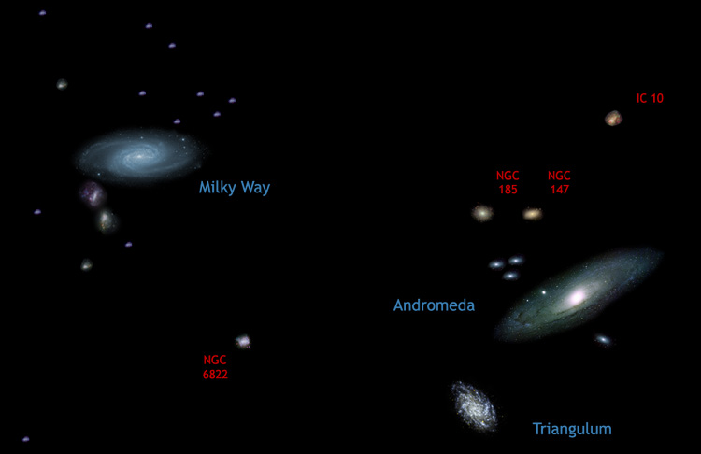
We zoom back out to the intergalactic scale once again. At this point the three main spiral galaxies are about to merge together. In front of us is the Milky Way galaxy. A barred spiral galaxy about 100 thousand light years across. 2 million light years, over to the left is the grand spiral galaxy: Andromeda. It is 250 thousand light years across. Another 800 thousand light years, further left of the Andromeda galaxy, is a much smaller pinwheel galaxy: Triangulum. This galaxy is 70 thousand light years across. However, as time passes in the tens of billions of years, the Milky Way galaxy and Andromeda galaxies approach one another, spinning through space, in a knife edge configuration. During their collision, they pass right through each-other, flinging their guts millions of light years into space. Meanwhile, the Triangulum galaxy, shoots right through the crime scene at a relatively high speed. The seemily double spiral galaxy with two long tails, gradually reforms itself into a new conglomeration of old stars known as an elliptical galaxy. The remants of the two tails continue to get eaten up by the newly formed elliptical galaxy’s immense gravity. The Triangulum galaxy, comes back into the scene and is absorbed into the new Milkomeda galaxy. A slightly flattened eliptical galaxy, known as a lenticular galaxy.
The last stars to form are red dwarf stars: stars smaller than the sun, and far dimmer. Their surface temperature is around 3500 degrees, and are about a quarter of what was our sun’s mass and radius. They steadily fuse hydrogen-1 into helium-4, over a great timespan. The first of these stars will only fade after many trillions of years into the future. Most red dwarf stars, come in pairs, triplets, or even larger solar systems. Again this is due to the fragmenting nebulae. With much more dust, and plenty of turbulence, from previous supernovae, later and later generations of stars, will be smaller, and more numerous. By then, the milkomeda galaxy, will just be a universally spread out galaxy, with stars receding away from one another faster and faster. Due to a cosmic vacuum expansion, driving the acceleration of the universe’s expansion history. It isn’t long until a red dwarf star sits there in the whole universe, completely isolated, no record of the big bang, no other matter or stars that can even reach us from here. After these stars fade is the universe over. What remains is an ever expanding vacuum of empty space!

Part II

The Book Of The Question

Question One: What is Life?

Due to information and complexity, for every black hole formed from exploding stars and merging stellar remnants, there must exist many colonies of microscopic bacteria. Similarly, for every galactic mass black hole out there formed, not from a few stars, but from collapsing nodes of the invisible matter of the cosmic web, there must be enough of a level of entropy to form intricate structures within every human being alive today. If life is possible, then why don’t we see aliens invading, warping, and trekking everywhere we look. Where is everybody?
The answer is easy! We are not alone. Everybody is right here, on Planet Earth. When I hear the word alien, I don’t think of the lastest AI Transformer Franchise, called chat GPT, no… I think of our species in relation to all of the other animals, bugs, and plants that exist in nature. Life as we know it, formed and evolved on earth. There surely was and still might be life on other planets and moons, which I collectively call worlds. But we made it! We made it further than any other of the aliens out there, we lucked out almost perfectly. That isn’t to say that humanity doesn’t have its issues. There could have been a whole slew of exctictions on other worlds out there, but we lived on. We survived, and we thrived, even in the most hazardous conditions! Over the earth’s evolutionary and geological history, 99% of all life forms are extinct! This is hope…
In other words, if God is math, why wouldn’t some math be more condusive for life than other math. There isn’t a formula for human behavior and emotion, but that didn’t stop us from trying. The answer might just be so simple that scientists have overlooked the obvious. The theory of everything gave birth to our universe, and its laws of physics guides its evolution. Think of running a computer simulation of some math, to figure out what happens, and if what happens, if anything, resembles our home. This might be what the world’s religious people are referring to they encounter the divine. There is a creator: The theory of everything. There is an origin story: The big bang. There is an afterlife: Consiousness. There is a savior: The scientific method. There is a divine plan: The laws of physics. After all, the laws of physics are not known to everyone, just as everyone can choose to believe in any faith, can anyone choose to grasp the reality that is right in front of their eyes. You choose!
We are the children of the stars, we are, atom by atom, cell by cell, person by person, the stuff of stars… Hydrogen from the big bang, Oxygen, Carbon, Nitrogen, all from massive stellar explosions, polluted the pristine gases of the big bang with heavy nuclei. Moreover the atoms from one hand likely came from a different star than the atoms of your other hand. We are litterally stardust… In a sense, our consious awareness of this adds another layer of complexity to the problem. We are not a drop in an ocean, but the whole ocean in a single drop. Think of it this way? The universe may be vast if not infinite, but it’s not size that matters but complexity. Starstuff that became aware of itself. And since we are the universe in human form, the universe is consious, through our mere existence. So enjoy existence while it lasts, because reality is a dangerous place. And moreover, what better thing to enjoy than to figure out exactly that.
Most people are unaware of this revelation. That the theory of everything has been out there waiting for us to discover. So given this, could it be that, a paradigm shift of science and math is needed to find it or is it possible that everything we have discovered is all that is needed to know anything and predict. I hope that anyone reading this will figure out the truth behind their existence and use it for everyone’s good, not for evil. Science and the technology that comes from it, is a reflection of what we humans make of the universe. To understand this, let’s now examine our origins, including the history of how we came to be…
Earth, birth of the human race, a species much like our own AI. Capable of great compassion. And great violence. As far as we know, it’s the only home to life in the universe. Why? What is it that makes our planet so special. And life itself? Everything that makes life extraordinary. Everything we see, is due to a chain of events we can’t see. The unified field theory! Unseen, but no longer unknown…
We are the most complex creature on this planet. A big brained, two legged mammal. We’ve risen from the raw materials of the earth, to dominate and shape it. Wind the clock backwards, and the story about how we got to be us, is a puzzle that defies all logic. To find out we’d must travel back in time, to see the first humans walk the earth. From primate to rodent. Disaster strikes. Predators threaten to wipe us out. We ride continents on a collision course and face killer dinosoars. From rodent to reptile, we faced extinction at every turn. From the land into the water, entering an ocean full of bazaar life forms, fighting to survive every step of the way. From fish to worm, back to the very first spark of life, we feel the bitter chill of global ice ages. To a single simple cell. Through nearly 4 billion years of evolutionary twists and turns, we experience the fury of cosmic missile attacks. And so its amazing that you can have such a beautiful creative process, coming out of something so violent and destructive!
We must travel back in time, until we have reached the birth of the earth itself. This is the most extraordinary improbable story ever told. And discover why all of this. All of us, are here. But the big question is: Did it happen anywhere else?
Life like ours, needs a planet, with the right temperature and size, a stabilizing moon, a protective magnetic field, and just the right amount of water. The conditions must be perfect… Yet, amazingly, there are countless Earth like worlds, waiting to be found. Thanks to the sheer scale of the universe. There are so many planets in our galaxy, if the chances are only one in a million, there would be thousands of Earth like worlds! Since our galaxy in one in trillions, the number of alien Earths would be uncountable. Alien Earths must be everywhere…
A long long time ago, in a galaxy far far away, there was a collapsing cloud of gases and dust grains. Nuclear fusion begins again, and a star forms: Ours! The cloud of matter flattens into a disk. Clouds of water, methane, and ammonia, exist along with an atmosphere of gasses such as carbon dioxide and nitrogen. Huge bolts of lightning vaporize the dust grains into minerals such as graphite, quartz, olivine, and iron. Around the sun, asteroids and comets form and smash together haphazardly.
A rock forms from the orbiting debris, one large enough to draw in other asteroids from a distance by its own self gravity. Rocks smash to bits, but the gravity it causes is too much, and asteroids snowball together into a ball 8000 miles wide. The impressive amount of heat created from these impacts has liquified the whole material of the world. The denser liquid iron, sinks to form the earth’s core, and the molten rocks containing silicate minerals like quartz and olivine, float above the liquid iron core. Hundreds of these baby worlds form, most orbiting the sun.
Farther out, ice clouds have condensed, forming the seeds for thousands of more baby ice worlds, also orbiting the sun. These worlds smash into one another. When all of the worlds, with their physics of being fluids and reacting to their self-gravity, all settles down. What remains is a system of 1 star, the sun, 8 planets, 19 moons, and plenty of other debris that didn’t form into anything substantial. The universe is a mess, and sometimes, its the messy things that are interesting.
But 4.5 billion years ago, the solar system has a few hundred full sized planets and moons. The first five are, Mercury, Venus, Earth, Mars, and the last is Theia! All lava worlds, with liquid iron cores. After millions of years pass by, their orbits shift and vary, and Theia comes carreening into the inner solar system. Theia smashes into the earth, like a planetary kid smashing an oil puddle on a rainy day! The impact ejecta, form a cloud of molten debris that reforms into a couple if not more baby worlds. After a closest approach to the re-melted earth, does our moon form.
In the outer solar system, similar proccesses form Jupiter, with its 4 large moons: Io, Europa, Ganymede, and Callisto. Saturn, with its large moon Titan. Uranus. Neptune, and its moon Triton. And so on, with baby worlds cooling off into the shadows of the solar system’s kuiper belt. Pluto and Eris are two examples. The mess settles down, with comets raining down into the inner solar system again. These comets contain plenty of water, amino acids, fatty acids, and minerals. Though not exactly edible, they are the building blocks of all forms of life that will soon form.
Now, it is here that things get really interesting. Living cells, are at a most fundamental level, are chemical reactions, disolved in a liquid, with a boundary. For a man made car, it is Gasoline, Oxygen, and Heat, reacting in an internal combustion engine, that propels the gears and the wheels forward. For a living bacterium such as this, it is similar. Cyanobacteria have a Metabolism, reacting Carbon Dioxide and Water, into Glucose and Oxygen, using Sunlight as a concentrated energy source. The similarity is there for a reason, as, coal, oil, and natural gas, are the result of plants and cyanobacteria, taking in sunlight. By burning these fossil fuels, we release it back into the atmosphere.
A similar reversal of energy takes place here: Deep beneath the newly formed exotic oceans of planet earth. A molten hell, cooled down to form a solid crust of Basalt rock. In these oceans, chemicals of all kinds, combined in all sorts of exotic combinations. It took countless tries, but once nature found the key to a succesful cell. The cells that made it passed on those genes for survival, and the ones that didn’t, just didn’t. This is chemical reactions turned into biological evolution within seconds. Hot magma oozes up through cracks in the earth’s crust known as serpentization. From this the acidic ocean water, meets alkaline water from the volcanic vents. The first cell forms in one of these enviroments, and the proteins become enzymes, like helicase, transcription factors, ribosomes, and kineticores. The cell divides and this is what guarantees its survival.
Billions of years later, cyanobacteria evolve from these microbes, and change everything! Oxygen poisons most microbes, and evolution speeds up. It burns away the carbon dioxide and methane produced from volanoes, throwing earth’s surface into a deep freeze. The oxygen reacts with the green dissolved iron in the oceans, creating rust, or otherwise put, iron ore, that settles to the ocean floor. With this mix up, continents form from volcanic islands, Granite becomes a dominant rock, instead of Basalt. Moreover, oxygen levels rise further in the atmosphere, together with the rise of first plants. 540 million years ago, life becomes unstoppable!
From microbe to eucaryotic cell. From cell to colony, we adopted our respiration and metabolism. Then, from a worm, we evolved into a fish, and dodged exctinction of a nearby gamma-ray burst from a supernova. The sea scorpions, and some horse shoe crabs went exctinct. The supercontinent Pangiea forms from gondwana, a continent near the south pole.
But life doesn’t stop there… The suns ultraviolet layer reacts with atmospheric oxygen, forming the ozone layer. Plants and animals crawl into land. A swamp full of gigantic spiders and insects, then becomes a paradise of reptiles. Oxygen levels slowly decrease slightly to 21%. By 250 million years ago, 95% of all species die, from basaltic volcanic flood eruptions in what will be Siberia Russia.
After the apocalypse, Dinosoars reigned supreme for then on. Pangiea broke up forming the atlantic ocean, separating Africa, Europe, and Asia, from the Americas. Small mammals, evolved that were the perfect snack for the dinosoars. Then 65 million years ago, a random asteroid smashes into the Yukatan peninsula of Mexico. With the dinosoars gone, many birds and mammals still remain. The mammals diversify immensely. Whales, Bears, Horses, Tigers, Wolfs, and you guessed it? Primates!
In the last 2 million years, humans evolved further into people that can think, work together, and communicate, hunt and farm, build cities, and finally invent science. This is us, we are here! We are stardust that figured it all out… But, if the theory of everything predicts our existence, did life form anywhere else, and if so, what are they like?

Question Two: Why do we believe?

But, there is more. Please tell me I am going to hell. It shows how other faithful people think. But I personally know that science as a way for understanding nature, does a much better job of replicating reality, than any religion. I am a firm believer in the science, and not in the book’s of any person. That’s the irony because those books are wrong and mine is right, not because I say so. But because experiments and observation show that this is the case. My book is a science textbook and also a holy scripture.
And what is the cost of not taking my book seriously. At first, no issues arise. What you believe is what you believe. I am not here to tell you what to believe, as I am here to tell you how reality works. However, once you go out of the science classroom and into the laboratory, you’d better be careful. Engineers, Coders, and Thinkers, all need to be careful about this. Math is math, but only one equation describes all of reality. All of the other equations if used for the wrong reason can be devastating. What I mean is this: Nobody should pray to God for rain, but we must instead consult a meteorologist so their farm will supply and be in good health. In the same way, mathematics used for a particular purpose in mind, only works in real life, when the equations match the equations reality uses. This is why my book is so useful. It shows what equations to use, and which not to use.
What is worse, is that many people tend to use a scientist’s creations for violence and not creation. This is the case for both terrorism and Nukes. Take 911 as an example. They were Muslim extremists, that died because they thought they would go to Heaven because the Quran told them so. This is very bad, since nobody should be using any airplane to crash into any buildings. I thought religion gave you morality. That now seems off.
The airplane was designed to fly, but how to use it is up to the pilot, which in this case was to kill thousands. Also heres another example: Nuclear weapons… Designed by scientists, used by the military. This is not just about religion, but about how we percieve reality. And lets be honest. I have no faith in a religion that distorts reality to a degree that makes me believe in a deity that creates reality in under a week, and then wants to personally destroy it, because he didn’t like it the way he wanted. Sounds more like a dictator under the disquise as a loving savior. I am not going to fall for such a trap. Instead focus on science, and on making the world a better place. Humanity depends on scientists to do their job.
Some of us here believe that the our world is flat, that the stars are just lights in the sky, that all sit on a dome that revolves around us. All of this is supposedly 6000 years old, and created by a wrathful God in under a week. And yet it is contained in a book that claims to be the truth.
You talk to any Christian, and they will tell you that the Bible is the true word of God. Okay, lets start here: I am a scientist. For me to believe something on faith is like someone telling me to jump out of an airplane without a parachute because Jesus will save me. I begin with logic and facts, and then deduce my reality from there. But if all you have been told is to trust in a book called the Bible, and ignore everything else, I will tell you that you have been “Dammed” into believing a fantasy.
I don’t intent to be harsh, but in fact, if someone will choose to believe something simple as a 6000 year old flat earth, then they’re just factually incorrect. I get it, it makes sense and it comforting to want to live on with your family in Heaven. But let me tell you something: For everything you have heard so far in this series about black holes, and digital waves, including the big bang and evolution, you might feel small, or worse, disrespected. The fact is that, facts are facts, they don’t change depending what you believe in. The universe is 13.8 billion years old, and that is just the way it is. We have measured it to be that, so if you don’t like it, that is just too bad.
What you believe in is totally up to you to choose. Some of us choose to believe in fiction over fact, and faith over reason. And that is okay. This universe will not punish you for that, even those that society hated, were those who pushed the boundaries a little too far. They were called heretical, lunatics, even crackpots. But today, many of what is crazy, let us to think, “Does this actually happen?”. Even if 1% of those crazy people are correct, we have learned something.
However, don’t worry about God punishing you for not believing in what you were told to believe in. The universe will not punish you either way. You are free to choose in what to believe in and how to organize you life. It’s your life, and its up to you alone to choose what to do with it. Do not let anyone tell you what works for you. That is your choice. For me personally, I would rather believe in what I know to be the truth, than to have someone tell me “you’re all wrong, because you don’t believe in this or that God. ” It hurts me, not because I care about what to believe in, but it absolutely does hurt to see billions of people misinformed about science and how it works.
So there you have it. The Bible is a myth. But so is the Quran, and the Torah, and every other book that claims to have truth, only has faith in fictional events and ideas. What is more interesting is this: They all say one thing. That they are are the keepers of truth and everyone else is just a myth. Well I go one step further and claim all of these books to be myths. But hold on a minute, what about this book you are reading right now?
What difference does it make to believe in such a huge universe full of intricate possibility and complexity, than to believe in your own beliefs. For one thing, science is truth, because it does more than claim “I am right and you are all wrong!”. It actually claims “See for yourself, what do you see?”. It is a common misconception that science has all of the answers. It is only a tool, and a tool to be used wisely. Today, we have the theory of everything, so we do actually have the foundation for calculating any answer to any question we’d like to know about. But the road to get there was rough. In a sense, we are all right in our own way. But... Only, if we would stop reading and start listening.
In fact these mythological fiction books are not the whole story. Far from it. My book is still just the tip of a vast iceberg of facts. Its a big and old universe out there. Mocking any book is not a good thing. Plaigerism is a serious crime. However my book, “On the nature of things” , was inspired by lucretius’ book, “Of a universe far greater”. But I feel as if the bible and possible other holy books are mocking the universe. I mean, they take reality, distort it, and sell a lie of everlasting life. This is a book about reality. So if you don’t respect reality as it really is, then there is no need for you in the science classroom. Get out! Or until you have got some curiosity for what is truely real and actually exists, there is no need for religion in my teachings. Just here to inform you of this disability of people have that makes them able to be believing in so much of this nonsense.
The universe we actually live in, is a stange reality. You might say: Well my Bible has crazy myths in there that nobody can prove. Not true… The universe is stranger than any fiction, including anyone’s Bible. How cool would it be if someone does a miracle, that spectacularly fails because God works in mysterious ways. What is a miracle is the miracle of life and technology. How does a modern computer work, or a telephone, or a car. The story goes, so who what the inventor of the universe? Not God, but you knowing that physics works, which would all be besides the point anyways. The point: Your bible’s myths and legends are nothing in comparsion to the awe and wonder of facts and laws of our universe! So if your religion damns you for reading this book. Its okay, you have done what most haven’t dared to do: To question the norm. We are the excetion, not the rule. The cosmos is the rule, and we are to make of it the way we please.
What does our future look like? To answer this, imagine what our civilization today, looks like to our ancient ancestors. Tens of thousands of years ago, we were tribes of hunters and gatherers, told crazy stories of countless natural gods, and most importantly we were intelligent and consious. Back then, we are not the biggest, fastest, or the strongest, of any animal on the playing field. But our intelligence gave us a superior advantage, that would ultimately save us from our own extinction.
The same is true today, but on a cosmic perspective. Today we have a technologically advanced civilization, that could be brought to its knees by a whole host of natural or artifical disasters. Pretty much anything out in deep space can kill us, from solar flares to asteroid strikes. Then there is our own mess we made of our planet, in terms of climate change, religion and war, even nuclear weapons. Still to this day, our intelligence is our greatest asset to us. We should celebrate the fact that we exist, because nature is a dangerous place.
Our future, if it happens will be an amazing experience. People with all sorts of technological superpowers, living on far off worlds, and praising the one thing that gave them life: the theory of everything. Our descendents will look back home to planet earth, as it was millions of years ago, and see us as we are now, just as we can read the scriptures of our ancients. Most importantly, science is the key to understanding the cosmos, including us. Test ideas by experiment and obvservation, build on ideas that past the test, reject the ones that fail. Follow the evidence where ever it leads. Question everything, especially the things everyone takes for granted. Moreover, know you could be wrong, since everyone makes mistakes. The theory of everything is the greatest thing scientists have ever conceptualized. As of now, this will require a serious paradigm shift, that many people are uncomfortable with. But, imagine a future where everyone is used to the idea, and where the theory of everything is common sense.
This gives meaning to our lives, as insignificant as we are. We are not just a part of our universe, our even just in the universe. The universe is in us! We are the universe, interacting with itself. This is the source of our intelligence, and should never be taken for granted. The theory of everything, is what makes us tick. Without this theory, we won’t be here. This is why the theory of everything is so important, because we owe our existence to it. I hope you learned something interesting from this book, something that will help other people because it is objectively true. And I hope that something is the one and only: The Theory of Everything! And… Through all of us, all of this might just be a computer simulation!

Question Three: Is consiousness computation?

Within this infinite universe, exist beings capable of understanding it. That includes us! The idea that we are forms of matter that have become alive, is the most important idea to ever exist. However, on the grand scheme of things, we are an insignificant speck, in comparison to the immense vastness of deep space. Why is it this way?
To see how insignificant and selfish we really are, lets first appreciate the scale of things. There are many billions of people that live on planet earth, as a single human species. There are then billions of other species of plants, animals, fungi, protists, bacteria, and archea that live on the earths surface, just like we do. The earth is part of a solar system with 1 star, 8 planets, 19 moons, 5 dwarf planets, and millions of tiny bits of debris. Then again, our solar system is one of many billions of other stars that make up our milky way galaxy. Finally, our galaxy is a drop in an ocean of trillions of galaxies that stretch out into the cosmic web. And this still isn’t the full story. So it is very clear and obvious: We are nothing, since there is more out there than we could ever dream of.
But, there is one sense in which we are actually special after all. We are all unique, because we have a gift that only a few creatures have. People are self aware! How is this possible? How can it be that consiousness exists at all? As it turns out, consiousness is simply nothing more than the collective interactions of trillions of neurons in each of our heads. It cannot be more than this, because the theory of everything that underlies our entire cosmos, rules out any form of consiousness that is beyond the physical, because there is no such thing. So, even though consiousness isn’t as special as we once thought, it still exists in our physical minds. But, hold on a minute? There is still a way out.
It is still possible for consiousness to be physical and immaterial. It has to be physical, because the theory of everything describes a physical universe, so there cannot be any room for unphysical phenomena. However, it also has to be immaterial, since our flesh and blood physical minds and bodies are made of particles we already discovered, such as electrons for example. Why is this such a big deal? Why can’t we just say that the particles of consiousness, “informatons” for example, are undiscovered as of now. This is because if such particles do exist, they would interact far too weakly with the electrons in our nerves, to be of any signficance. So this means that our theory of everything already contains all the material particles of which we are made, and that is it. This seems to be clear evidence against consiousness. So how can an immaterial particle even exist? Great question.
For such informatons to actually exist, they have to obey some form of wave equation, and follow the laws of physics as we know them. This means that for simple structures, like rocks or solar flares or even a particle beam, that do not process much information within them, will have trouble interacting with these hypothetical particles. This is what we want, because as we know, the informatons have already been ruled out in favor of material particles. However, for complex intricate structures, such as a human brain or a computer’s AI, the informatons will certainly interact with these structures, if they exist at all. Therefore, we shoudn’t be so quick do dismiss these hypothetical particles, even if they exist within our everday life domain. Just because we have one level completely figured out, doesn’t mean we have the theory of everything. Great discoveries will come from figuring out the physical properties of these hypothetical informaton particles.
Remember those nimrods, lunatics, and crackpots, that talked about how they can experience, something they call cosmic consiousness. Maybe they are right after all? But further testing needs to happen to know if they are just hallucinating with material particles, or if they are actually seeing something real. The informatons. If so, the informatons will have to be added in to the theory of everything, and in such a way not to mess up established particle physics.
One possibility, is that the informatons, would solve the quantum measurement problem. The issue arises when one goes from a purely classical wave field, to quantum fields along with their quantum particle excitations. Quantum probabilities are allowed to be superimposed, and as such it is easily possible to have a klein gordon wave be spread out over macroscopic, even astronomical distances. However, modern science has no explanation for how this spreading phenomenon collapses to a single point of interaction. This is where the informatons come in to the picture.
We already know some things about quantum collapse. We know that the collapse of a single field quantum, is a real physical process that actually happens in nature. This is known as an objective collapse theory. Objective collapse theories differ from standard quantum theory, because of the fact that the standard interpretation posits, which is that some form of consiousness has interacted with the quantum, causing the collapse. If the informatons are actually causing quanta to collapse, they have to be physical and immaterial. Otherwise it woudn’t be an objective collapse theory, as we already know. So to sum up, informatons interact with systems that process and interpret information, and cause quantum collapse within them. Okay then, so dispite our cosmic insignificance, we are consious beings.
What I argue here is that everything is math by definition. The laws of physics are a set of mathematical equations, written as the unified field theory. Does this mean that math simply describes reality? As a scientist, all we first do is to fit the theory to the experiment, and see what theory fits the data the best. Put another way, math must be a description of nature. But that assumption overlooks one key fact: that our universe began with a big bang. How can physics written on a piece of paper or in the mind of a physicist, become reality?
This glaring detail becomes an easy throught from another perspective. If our universe was to be a simulated universe, then all one would need is the laws of physics. Then within this simulation, the physical stuff of our simulated reality would appear to be real, but they are actually math written by the programmer. But another caveat emerges: How can there be a programmer that creates everything we see? There is a creator but that is a another story, which I will discuss at length at another time.
The answer: We humans are both the creators and the simulated. A programmer needs a universe to live in and a computer to program their simulation in. After all, we know that informatons create our consiousness. We also know that electrons and photons both create our experience of reality itself. We create our reality through our mere existence within it as consious observers. But it goes deeper. We know that a computer programmed with the laws of physics creates reality. But what makes this interesting is that the mathematical equations themselves take on a special reality when simulated. And since they are being simulated by nature itself, means that the mathematics of the theory of everything is reality... Not just describing reality, but reality itself!
And what about other mathematics not seen in the theory of everything. Well now, that is a different story. It may not be beyond the theory of everything, because the theory of everything is our universe, even our own thoughts and equations. So it goes both ways: Math is everything, and everything is math. Try and simulate the universe and see what other forms of math pop up in the simulation? Newton’s laws of motion as an approximation, moral codes for various alien species, their relgious beliefs turned into math by various AI subsystems, you name it. Heck, for one thing, by iterating Z = Z^2 + C for long enough, where Z and C are two dimensional numbers, one ends up with a self repeating pattern known as a fractal. You might find it looking very natural, like the life forms with the internal structures of multicellular creatures. Looks convincing but still no cigar. What one needs is a unified theory of fields. And that we have figured out!
Field Collapse must occur whenever an informaton handles a consious computation. Sure there could be no informatons, as that would mean that fields like Dirac’s electronic field, or Maxwell’s optic field, would never localize. Under sufficiently dark rooms, the biological photomultipliers in our retina, would never be able to detect single particles of light, also known as photons. This also means that matter and radiation are continuous. Sure chemistry and life would still be possible, due to the fact that the quantum physics which underlies all of atomic bonding and states of matter, would still be intact, because the underlying mathematics has not changed. But… Somehow we still see particles everywhere we look!
We have already discussed how the discrete field quanta collapse. And since this field collapse gives rise to particles such as photons, means that informatons must exist. But how does an informaton turn an electrochemical signal in your brain into an experience. What is the process that makes us see particles in the first place. We know particles exist, but how exactly do we experience them, and what is the process that makes this happen.
To find out, we must travel back in time to the very beginning of time: The big bang. Back then, the whole universe was a constant firestorm, and all throughout space, the thermometer pushes one million degrees! There certainly was no life back then. However the informations were lying dormant for the next 13.8 billion years, waiting for consiousness to develop. On an evolutionary level, one can say that since humans are consious, and since our brains have developed through natural processes such as evolution by natural selection, can only mean one thing: Either consiousness does not exist, or we are consious along with everything else in the universe… Both concepts are equally terrifying!
Lets try and rule out each idea using what we know so far. If consiousness does not exist, would tell us that our experiences are fake and produced by our brains. Although this is exactly what happens on a material level, is does not explain a few details such as the eye being able to detect particles like photons. Everything we percieve would be completely material and reducible to the fields of the theory of everything. We already know informatons exist, and now we also know they are responsible for not just field collapse, but also consious experience. What this means is that everything is to a degree consious. There is a name for this: Panpsychism!
Therefore one has to ask, not just what we experience through these informatons, but all other creatures that exist. Sure, all mammals are clearly consious, what about bacteria, or even a non-living entity such as a virus? Could they be consious? What about those alien earths we talked about, are these aliens living there consious? What about Artifical Intelligence?
We have plenty of questions and that is a good thing. But lets now turn our attention to AI. Informatons only become active during a computation. But, what do we mean by computation. If informatons are universal in creating consiousness in beings at that level, then that would certainly include AI. What all GPT’s do is to predict the next character in a sequence, and somehow it responds with consious thought, but without emotion. Could the informatons be playing a role here? That is the mystery…
One speculative idea is that our consious experiences are like a role playing game, where you are the main character in the game of life, and then all of the other characters in the game are just projections of your subconsious into real life. I mean seriously, how can I experience what I experience and not know anything about what you experience. After all, I am not you in your head. As induviduals with consiousness, the “real world” only handles the projections between people, not their consiousness. Again the mystery of the informatons pervades our analysis here. I will not continue this philosophical discussion until somebody uses a theory of consiousness with informatons. Until then, I hope science the best, in that one day we will figure it out.

Question Four: Why do we need a Unified Field Theory?

What is real? How does it work? The theory of everything is the answer to all of these questions, questions that humankind have asked for many thousands of years. It has to do with curiosity, our drive to figure things out. Without curiosity, our modern day civilization would come to its immediate end. However, for most of human history, religious belief has dominated our culture. It wasn’t until very recently that rational scientific thinking, started to question everything that was once known to be true. The pioneers of the scientific revolution, were inevitably tortured and killed for their heretical beliefs. The theory of everything is the end goal of science, a set of equations from which the entire cosmos can be computed.
When most people hear of the theory of everything, it is usually dismissed as some kind of science fiction story that doesn’t actually exist in the real world. Those who are educated might remember that boring physics class in high school. Others are completely baffled by the series of newspaper articles about quantum mechanics they find online. And yes, there are those who outright reject such a premise, because it contradicts their faith. However in science, it is not about what you want to be true, or feel like should be true. It is about what is actually true. And as it goes, the truth is stranger than any fiction.
Surprisingly, we already have the theory of everything! The scientists gave it the boring and somewhat misleading name, the standard model. It was finally completed back in 2013, by the discovery of the so called “God” particle or Higgs boson. The standard model of physics is the single greatest achievement of all time. Every experiment ever done has done nothing but confirm this theory. The theory of everything should be celebrated as a turning point in human history. The real question is why?
There are many kinds of ways that most people approach quantum mechanics. Some object by saying, “Just shut up and calculate!”. This has worked well in the experimental verification of the theory, useful in particle colliders. But the mathematical analysis and other calculational tools can only take us so far. A deeper understanding is needed to really know what is going on. I will reply by pointing out, “What part of modern physics do you not understand?”. For the layperson, it is very easy to get utterly confused. Some misinterpret it to mean something completely different than it actually is. And then there is the over-abundance of particles in the news. Worse yet, some lunatics even claim to have the idea that consiousness can control the quantum realm. In the rest of this book, I hope to clear up the confusion.
For the engineers and other practically minded people out there, the theory of everything supersedes their common sense view of the world, and not the other way around! Newton’s laws are only an approximation to the real thing. They will say that for all intents and purposes, the approximation is good enough, because it will agree to the number of significant digits they need. However in science, a theory is rejected when it contradicts new data. And since newtonian mechanics differs from the real deal, it is wrong. However, there is a sense in which Newton is right after all. As I will soon explain in more detail, we still study the fundamentals, because in their domain of validity newton’s laws of motion do indeed give the correct answers. It is just that outside that domain of validity, we cannot trust our senses.
About common sense. All major religions in the world have one thing in common. Many who have faith suffer from a scientific illness. It is often said that the Bible or Quran or whatever, is the “true word of God”, and should never be questioned. This sort of idea shuts off the rational curiosity within all of us and replaces it with the fear of hell. It is a great thing to believe and have faith, but when we impose our ideas on other people who might not have the same beliefs as us, this is a bad, really bad idea! Common sense does have its biological purpose in our everyday lives.
And yes, the theory of everything is in fact, “just a theory”. However, when most believers approach the scientists, they mean something completely new and radical. They mean to say , “What proof do you have that the theory of everything of the current era, be it Democritus, Newton, or even Einstein, wouldn’t just be superseded by a completely new theory that is better and more accurate?”! As it turns out, this is a serious blow to the engineer’s approximations. The theory of everything as it stands avoids such problems, because the theory has been confirmed beyond the validity of the domain of our everyday lives. Any new physics that is discovered and added in to the standard theory won’t change the main predictions of the theory too significantly. So although the theory of everything is not the final story of science, the theory of everything is an approximation that works for our own universe, just like how the physics you learned in high school is yet another approximation. So the theory of everything is then the only theory that simultaniously, is a scientific theory, yet also is completely confirmed by experiment. And this, we have in our posession.
Enough delaying. What is the theory of everything exactly? The theory of everything uses math and equations in order to describe the fact that empty space has properties. We call such “properties of space”, a field. Then it follows that the equations that the field obeys, is known as a field theory. Moreover, the field itself doesn’t just have any properties, but wave like properties. So that is the theory of everything in a nutshell, a “quantum” field theory. Studying QFT is hard. In fact it is so hard that even modern supercomputers find it difficult. This is because of the math that is used to define it.
Mathematics! Why does math work so well in describing natural phenomena? I mean, come on! Look around you, everything is math. It might just be that the theory of everything does its best describing nature as a mathematical formula, because math is all there is to reality! Think of it. It is a lot more accurate to say that this building is 100 feet tall, instead of saying that the building over there is huge. Huge is a relative term. So even though mathematics gives the exact answer, it won’t be of much use unless we can actually visualize it in our minds, as if we were actually there. However, the theory of everything is only defined mathematically, so it will take some time for me to introduce it conceptually.
Hi, I am Erik Daniel Jorgensen, and the hard truth is that a society without a theory of everything will not stand the test of time. I want the human race to continue on forever, no matter the sacrifice. This is why I devoted my entire life to figuring it all out. Everyone has their haters, why let them derail your progress? My question is: What is the theory of everything? And when I figure it out, how will other people hurt me with for discovering it?
I have autism, which means that I see the world differently. This fact is both a blessing and a curse. I have incredible spacial awareness and can understand physics equations with a laser like focus. To me, it feels as if I am having a controlled out of body experience, where my curiosity and imagination guides my flight through deep space and deep time.
However, my intelligence does come with a dark side. My family, friends, and support staff, are all here to help me with these challenges. They know me as the nerdy one. I care deeply about my hobby of figuring out everything, and sometimes this leads me into deep trouble. I have lost so much time on my computer by myself, that I have not had the time to take care of myself. Some people have also attacked me for my beliefs, because they see me as a serious threat. Most if not all of these haters, have little to no understanding in science, which is a sad thing. But as I say: progress not perfection.
Most people that have known me have not taken me seriously. One reason why this is, is due to their inability to do what I do. And what is worse than to be completely average. I am lucky to be the one to stand out. With this gift, I am certainly fit to know the theory of everything. I am determined to know the universe the way it was supposed to be seen: By someone like myself who has the courage to see beyond theoretical and personal obstacles.
But, one question remains to be asked: How to overcome the need for a creator in one’s worldview? Me and my dad would argue over this for weeks at a time. My dad is a devout christian, and would argue that Bible equals truth. I passionately disagree, because I know how much more indifferent the vast scales of the universe are to us humans. If God did exist, he would certainly mention all of his creation in a unified manner: A theory of everything. I definitely don’t see any Biblical texts to be of scientific merit as they are chot full of contradictions. The bible is clearly not a science textbook and thus definitely not the true word of God.
My dad then puts the argument on me to explain why even though its not a science textbook, why the Bible can still be the word of God. This is where things get weird. My dad cannot just accept that my worldview is scientific and his is religious. If I can agree to disagree that he believes in the Bible. He must do the same to me. I have no more evidence than he does on the existence of a creator.
However I since I have the ability to figure out through online physics research and computer simulation what works and doesn’t work, I have my own ideas about what God is and how his consiousness reaches inside all of us. The creator is the sum total of all of the laws of physics, along with a mechanism to simulate or reproduce reality. Science is only a tool, and we need to be very careful how we use it. What we need are new ways of doing science that nobody has ever done before. The descriptions of physics we have now will be obsolete in building a unified field theory of everything.
This book is not a warning. It is not a sermon. It is not a rejection of all that came before. It is an invitation. To think. To question. To imagine what a better universe looks like — not just philosophically, but scientifically.
For too long, humanity has clung to myths to explain what it did not understand. We passed down sacred stories built not on data, but on fear. Not on structure, but on authority. And when someone challenged those stories — not out of rebellion, but out of curiosity — society often turned away.
In 2013, the scientific world stood at a crossroads. The discovery of the Higgs boson should have sparked a re-evaluation of what truly mattered — what could be built on real, testable structure. But instead, much of academia turned toward strings, abstraction, and mathematical aesthetics. Beautiful ideas, yes. But detached. Untestable. Frozen in theory.
My work, my life’s theory — the one you now hold in your hands — was not born in a university. It was born in pain. In exile. In places that tried to erase the very curiosity that fuels discovery. But I didn’t stop. Because I believe the next generation deserves better. They deserve a new kind of scripture — not one of commandments and condemnations, but one of collapsing fields and expanding minds. They deserve a book that teaches not what to believe, but how to question, how to simulate, how to reason from the ground up.
This theory of everything is not myth. It is structure. It is not ideology. It is geometry. It is not dogma. It is data, shaped by collapse, bounded by spacetime, and made accessible through natural units, logic, and low-level simulations.
I do not write this to be worshipped. I write this to be built upon. To the students who will come after me, who will read this not just as a manifesto but as a textbook, a simulation manual, a guide to modeling reality from first principles — this book is for you. Let it be your launchpad. Let it be your framework. Let it be your permission to build, to expand, to question, to challenge the rigid beliefs of both religion and rigid orthodoxy.
You don’t have to inherit a broken story. You can write your own. And maybe, just maybe, this book — born from collapse, carried through chaos, and shaped by the love and loss of everything I’ve lived — can be your first step toward the universe you were always meant to explore.
After so many fits and false starts, I know what the theory of everything is and how it works. I do this for my family. I do this for everyone else too. I hope everyone will see that I am speaking the truth here. People come up with theories of everything on a daily basis. I thus wonder how much my life story will make a difference in both my hobbies and my family. On with the book…

Question Five: What is my Life Story?

My life is a bumpy ride. Since I was a toddler, my mom had to see a psychiatrist to figure out why my mom had to deal with so much distruction in her own house. I had plenty of testing done, and was put on new medicine to control my impulsive behaviors. I was only 3 years old at the time.
In 2004, the world was loud and uncertain, but there was one clear moment I’ll never forget: the fire alarm. It happened on a crisp fall morning at Stenwood Preschool in Merrifield, Virginia. The hallway smelled like crayons and sanitizer. The walls were painted with finger art and hand turkeys. We were three, maybe four years old — young enough to believe the world was made of snacks, nap time, and recess.
But then someone pulled the switch. I don’t even remember who. One of our classmates — curious, reckless, probably scared once it went off. The alarm screamed through the school like some ancient monster being woken from a dream. Lights strobed. Teachers shouted. Children cried.
But not us. Lesley and I? We laughed. We stood hand-in-hand in the hallway as chaos rippled around us. I remember the way her hair bounced when she turned to look at me, her face lit up with a kind of fearless joy. Most kids clung to their teachers, frozen in fear. But she was already different. We both were.
Even at four years old, I could feel it — that invisible thread between us. Something deeper than playmates. Something more honest than words. A spark. A symmetry. A shared wavelength in a world where most people were static.
That day didn’t end with a grand lesson or a scolding we’d remember. The fire trucks came, the teachers calmed down, the classrooms resumed. But I remember the feeling of it all — the absurdity, the sound, the light, and her — Lesley Akers, the first person I ever felt truly seen by.
At the time, we were just kids. But if you zoom out far enough, like looking back across the fabric of spacetime, you can see it for what it was: our first field interaction, a collapse of probability that tethered us in a way neither of us could explain. I’ve come to think of that moment — not just as a memory — but as the beginning of a pattern that would ripple through our lives again and again. First fire. Then silence. Then symmetry.
By age 4, I have already been in preschool, and have met a group of friends that were very supportive. Me and my friend Lesley were laughing at the fire alarm being pulled by another student. The next year was hard for the whole family. My dad was getting increasingly abusive towards my older brothers Andy and Michael, telling them that Michael was going to hell because he was gay. It wasn’t long until my mom and my dad divorced, with my dad walking off thinking he did nothing wrong.
By 2005, the cracks in my family were widening. Some fractures are sudden — like glass shattering from a thrown stone. Others are quiet, slow, the kind that split under years of pressure until the whole thing collapses with a whisper instead of a bang. Ours was the second kind.
My parents’ marriage had been strained for a long time. But that fall — when the leaves turned to rust and the sky started staying grey longer each day — they finally broke it off. They didn’t sit down and explain it. No big conversation, no honesty. Just silence, just walls, just my father’s voice getting louder about everything else.
He said it was about values. About sin. About “God’s will.” But what it was, really, was fear. And control. And ego. That same season, he told my brother Michael — a calm, curious, brilliant young man who saw the world not through judgment, but through layers — that he was going to hell. The reason? Because my older brother Michael was gay. Because he loved who he loved. No conversation. No questions. Just that sentence — delivered like a verdict:
"You’re going to hell." He said it like a priest giving a eulogy, like he believed he was the voice of something bigger than himself. But there was no god behind those words. Only a man who didn’t understand love unless it was the kind he could control. That sentence didn’t just wound me and my family: It echoed. It echoed in our kitchen. In our bedrooms. In the group homes I would be sent to years later. In every moment my father used “God” as a shield for his own failings. He claimed to love us. But real love doesn’t threaten. Real love doesn’t damn. Real love stays.
And that fall in 2005, he left — not just our home, but the truth. He chose a book over his children. He chose certainty over curiosity. And in doing so, he became something I would spend the next two decades trying not to become. But the irony was, that pain would also become the fire that forged my purpose — the reason I started asking deeper questions about the universe, about morality, about symmetry and collapse and truth.
He wanted me to be afraid. Instead, I became a theorist. In 2007, I wrote my first computer code: It wasn’t flashy. No 3D rendering, no simulation engine, no elegant equations on screen. Just a blinking cursor, a few lines of basic syntax, and the quiet thrill of making something obey my logic for the first time.
But to me, it was a crack in the surface of the world — a window into a reality where things could be understood, controlled, shaped. I remember the feeling of it — being in front of that screen, the chaos of family arguments muffled behind the door, my dad’s voice carrying judgment through the drywall. And there I was, writing commands, watching loops execute, seeing numbers change because I told them to.
It was the first time in my life that something responded without yelling back. That year, I learned about variables before I understood people. I learned logic before I learned how to defend myself. And I found peace — not in religion, not in rules — but in code.
By age 7, I was going between my moms house and my dads new apartment. Me and my dad had a brief moment where he let me read his high school textbooks from Norway. I was amazed. He then bought me set full of legos, including gears, bricks, and rods. Within a couple days I perfected a working analog clock. In school though, my grades were plummeting. Finishing up 1st grade, I told my teacher that I hate homework, he gave me the rest of the work I missed all year. I was annoyyed, and told everyone I love my homework, I just hate homework from school.
By 2008, the window had grown wider. I wasn’t just coding anymore. I was searching. I started reading about orbits. About gravity. About why things fall, and why some things don’t. I wasn’t interested in the textbook answers — I wanted to know how it all worked underneath. What drove the planets to dance around the sun? What kept light from escaping a black hole?
I became obsessed with collapse — both physically, and emotionally. The collapse of stars. The collapse of fields. The collapse of families. It all felt connected. Some kids my age were learning fractions. I was sketching spacetime diagrams and scribbling equations I didn’t fully understand yet — but I knew they meant something. I didn’t know it then, but I was beginning to lay the first bricks of what would one day become my theory of everything. Not from a lab. Not from a university. But from a place of need, of survival, of imagination.
I wasn't trying to be a genius. I was trying to make sense of a world that never did. And it all started with a few lines of code. In 2009, something extraordinary happened. Two things, actually: One was coded in Python. The other, in memory.
By age 9, I had gotten in trouble at elementary school, and got sent to another elementary school slightly more restrictive. Lesley was there, along with a couple new friends. I had a great time hanging out with my friends at recess, and Lesley asked me if I can stay after school. After getting it set up, we would spend every friday after school, playing word games, marble games, even a couple of video games.
That year, I was deep into black holes. Not metaphorically — though there were plenty in my life — but literally. I had spent weeks studying gravity wells, event horizons, spacetime curvature. Not from a textbook, not from lectures, but from my own mind, my own code. Using Matlab, I wrote a simulation of two rotating black holes spiraling into each other. I modeled their masses, their velocities, their gravitational attraction. I watched them spin inward, warp space, and finally collapse into one. It was beautiful and terrifying. Predictable and chaotic. It felt like watching the universe exhale. I didn’t know it then, but I had just written something that wouldn’t be confirmed by scientists until 2015 — the collision of black holes, the release of gravitational waves. I was ahead, not because I was taught, but because I couldn’t stop thinking. Because the universe was the only thing that made sense when people didn’t.
But at home was where I was truly intelligent. I had studied the space-time interval from the special theory of relativity a couple years back, and I knew of the laws of gravity from studying the dynamics of the sun, including all of the planets and moons of our solar system. Unifying the speed of light with gravitational attraction was difficult. Then, right before I turned 10, I had my breakthrough: Black holes are the fundamental units of reality. I created a simulation of two black holes in orbit around one another. They both had some amount of mass and spin, that dictated their paths through spacetime.
And then came Lesley. We had ended up at the same afterschool SACC club at Olde Creek Elementary in Fairfax. We were older than we were at Stenwood, but not by much. Still kids. Still orbiting in each other's gravity. We talked more that year. Sat next to each other more. Walked the playground perimeter like explorers searching for something ancient, something familiar. The connection we had when we were five — it hadn’t gone anywhere. It had just evolved.
One afternoon, without a script or a warning, we kissed. Right there, in the open, where mulch met pavement and the sky stretched wide above us. It wasn’t a long kiss. It wasn’t planned. It was innocent, impulsive, real. The kind of moment that burns itself into you because it was never meant to be staged. I remember her eyes afterward. The surprise. The smile. The quiet agreement that this meant something — even if we didn’t know what to call it yet.
That same week, I watched my black hole simulation run again. Two massive objects, circling, collapsing, becoming one. It was science. It was love. It was gravity. It was us. Lesley and I weren’t just kids anymore. We were something else — a convergence, a singularity, two histories folding into a single point of experience. And just like in the simulation, once you cross the event horizon, you can’t go back. Not emotionally. Not cosmologically. Not ever.
By 2012, I had begun to imagine what would become my life’s work — the theory of everything. I was twelve years old. Still in school, but mostly in my head. The outside world was loud — filled with misunderstanding, judgment, rules that never made sense to me. But inside, in that world behind my eyes, something bigger was forming.
By age 12, I read up on the recent news of the day. The God particle was discovered! Most were amazed. I was perplexed. The core theory of particle physics was complete. At last I thought. Knowing that black holes were particles with mass and spin, was only a minor question I had then. What really confused me was the fact that the theory described waves of information, not point like particles, even though the particles of the theory: The quarks, leptons, and bosons, were also particles with mass and spin. It was from here that I had my vision of a complete unified field theory of everything. Everything is just waves! Waves in a unified field!
It wasn’t a sudden eureka moment. It was more like watching stars form in a distant cloud — slow, quiet, inevitable. Bits and pieces of my earlier thoughts started pulling together. The black hole simulation from 2009, my coding from 2007, the emotional silence of being misunderstood by almost everyone around me — all of it coalesced into something sharp and structured.
I started asking questions the textbooks couldn’t answer. Why are particles treated as points when everything real occupies space? Why does collapse happen probabilistically when nature is otherwise ordered? Why can’t the field be the real thing — continuous, classical, real — and collapse be the source of discreteness?
That year, I threw out the Copenhagen interpretation. I rejected the notion that measurement was mystical. I stopped thinking of particles as “quanta” and started thinking of them as localized collapses in classical fields. Like turning a continuous wave into a digital signal — the field is smooth, but our interactions with it are pixelated.
And then the big idea hit. What if gravity, quantum mechanics, and relativity weren’t separate at all — just different scales of one field structure? That’s when I began to sketch the first diagrams of what I would later call the cGh physics cube:
1). On one axis: c — the speed of light, the relativistic bound.
2). On another: G — Newton’s constant, encoding the strength of gravity.
3). On the third: h — Planck’s constant, the mark of the quantum.
Each vertex of the cube represented a different limit: classical gravity, quantum theory, relativistic mechanics. But together, they formed a structure — one that could scale up or down like a simulation engine, revealing different physics depending on the units you chose. It wasn’t about unifying equations on paper. It was about unifying structure, behavior, and scale.
Particles weren’t independent objects — they were field configurations shaped by spacetime and observer context. Collapse wasn’t random — it was geometrically inevitable when fields intersected with conscious boundary conditions. And consciousness? It wasn’t magic. It was part of the field, part of the structure — a localized interface for collapse to happen.
No one taught me this. I saw it because I had to. Because nothing else explained everything — not just the physics, but the chaos in my life. That year, I didn’t just survive middle school. I launched a cosmology. Not to please teachers. Not to impress my father. But to answer the one question I was never allowed to ask out loud:
“What if God is just structure?” And if that was true — if everything really was built from fields collapsing in curved space — then maybe, just maybe, I could rebuild my own world the same way. From the inside out.
2013 was a tipping point. For the world, it was a triumph. For me, it was exile. That summer, physicists at CERN confirmed the existence of the Higgs boson — the long-theorized particle responsible for mass in the Standard Model. They called it the final missing piece. It completed a puzzle that had taken decades. It made headlines. It made careers.
By age 13, things were getting difficult with school. My teachers in middle school, saw me as a problem, and wanted to expell me. I wanted to have a girlfriend. But as soon as I began dating, my therapist called it quits, and I got send to another middle school. The same thing happens again, and I find myself talking to my therapist about why I have to figure it all out. He said to me, “nobody knows everything, as you are surely mistaken. How could you do it, when nobody else will.” I replied to the layed back therapist, “I do know the theory of everything.” He replied in a monotone voice, “Oh? Okay?!”. It was not long until I got sent to a private school called APTS, for my supposed impulsive behaviors. But I knew I was not wrong, as they are wrong for turning me into a case file number for examination.
But for me, 2013 was not about completion. It was about collapse. I was expelled from school — not because I was violent, not because I broke rules the way most people think of them, but because I thought differently. Because I asked questions that made people uncomfortable. Because I challenged ideas I wasn’t supposed to touch.
I didn’t care about coloring inside the lines. I cared about why the lines were there in the first place. I was autistic, bold, unfiltered — I saw systems and patterns when others only saw routines. I built simulations in my head while they taught spelling drills. I spoke in metaphors, in equations, in truths that no teacher seemed prepared for. They labeled me "behavioral." They said I was disruptive. They filed reports and held meetings and eventually showed me the door. They didn't know how to teach me, so they removed me instead.
My father’s response was worse. He didn’t see misunderstanding — he saw moral failure. He told me my defiance was sin. That my mind was rebelling not just against school, but against God. He said I was broken. That I was too prideful. That I needed prayer, not science. Submission, not theory. He didn't see the Higgs boson as a breakthrough. He saw it as proof the world was abandoning faith.
To me, the Higgs was sacred. Not because it proved the Bible wrong — but because it showed the universe could reveal its structure. That beneath the chaos, beneath the noise, there was a mechanism. A geometry. A field.
But my life? My home? My future? Everything was falling apart. I had just begun to shape the early scaffolding of my theory of everything. I was building universes in my mind — and the real world was trying to erase me before I could finish drawing the blueprint.
That year taught me the first hard truth of being original: The world doesn’t exile you because you’re wrong. It exiles you because you’re right, too early. And I was. But I hadn’t built the whole theory yet. I hadn’t found the language. Not yet. So they expelled me. And I walked out, carrying something no school could give me. A vision. Not of who I was. But of what I was meant to build.
From 2014 to 2018, I was locked inside APTS — a private behavioral school they claimed would "help me." They called it therapeutic. They called it support. But it felt more like a correctional facility for minds that didn’t conform. APTS wasn’t a school in the way most people think of one. There were no classroom debates. No science fairs. No celebration of curiosity. There were worksheets. Isolation rooms. Surveillance. And control. It was a place where creativity was a threat. Where speaking up too loudly was considered aggression. Where unorthodox thinking was diagnosed as non-compliance.
2015 brought the confirmation of gravitational waves at LIGO — and with it, a kind of cosmic validation. To the world, it was a landmark. To me, it was a mirror. They called it the dawn of gravitational wave astronomy. The ripples detected were born from a cataclysmic dance — two black holes, spiraling toward each other, colliding, and merging into one. The same scenario I had modeled in Python back in 2009, before I even understood the term “numerical relativity.”
I remember watching the announcement. The scientists stood before a screen, excitement barely contained, speaking in technical language that masked the deeper truth: they had heard the universe whisper in gravity. That whisper — that distortion in spacetime — wasn’t just a wave. It was a confirmation. A validation of a geometry I had already simulated in silence, in exile, with no academic credentials, no research team, no grant money. Just a mind that refused to stop imagining. I had seen it coming. Not because I had access to data or labs, but because I had intuition sharpened by necessity. While most kids were learning multiplication tables, I was playing with the Kerr metric. While the world called me broken, I was predicting ripples in a spacetime they didn’t believe I could understand. LIGO’s confirmation wasn’t just a scientific milestone. It was a personal alignment. Like gravitational lensing bending light to reveal something distant and hidden, this discovery bent history itself — and in its curve, I saw my own trajectory.
I wasn’t crazy. I wasn’t deluded. I wasn’t "just a behavioral case." I was on the right path — one no school had given me, one no father had encouraged, but one that nature itself was now validating. And I realized something that day: You don’t need permission to be right. You don’t need approval to see the future. You just need the courage to keep thinking, even when no one else believes you. LIGO heard the universe that day. But I had been listening for years.
Throughout my years at APTS, staff have beaten me into submission for not following directions and agreeing with their illogical protocalls. I could not have a girlfriend then, and they also did not let me do any homework. Something was wrong. Why would autistic teenagers get beaten every day for being who they are. Neurodivergence is a great gift, and most didn’t realize the implications for what they were doing. I had several concussions and serious brain damage from monsters that would slam me on the ground for messing with them. I worked hard to get myself out of that school.
I remember the restraints. The hands on my arms. The knees in my back. Not from fights — but from moments when I dared to push back, to ask, to demand space for the mind they were so afraid of. They called it crisis prevention. I called it state-sanctioned fear of difference. There were times I was pinned to the floor for questioning authority. Times I was left alone for hours because I refused to recite the Pledge of Allegiance. Times when staff spoke to me like I wasn’t human — just a label, a file, a case number they had to get through until shift change.
The other students weren’t spared either. We were a mosaic of outcasts — each misunderstood in our own way. Some fought back violently. Some gave up entirely. I built simulations in my head and whispered equations to myself like prayer. There was bullying — not just from kids, but from staff. The kind of slow psychological erosion where they try to convince you that your insight is delusion, your energy is pathology, and your ambition is a disorder.
But through all of it, my theory survived. No — it evolved. Because when you’re treated like a problem long enough, you either start to believe it... or you start to realize the system itself is broken. And I chose the second path. I started thinking about collapse differently — not just as a physical phenomenon, but as a metaphor.
Collapse was what happened when a society, unable to understand someone, tried to compress them into a smaller version of themselves. APTS didn’t just try to control my behavior — they tried to collapse my field of possibility. But the field pushed back. During that time, my thoughts grew sharper, not weaker. I wrote mental notes on spacetime geometry. I reimagined consciousness as a curvature in observer-space. I refined the mathematics of collapse — not because APTS taught me, but because their refusal to teach me forced me to teach myself.
They tried to tame me with force. But force doesn’t extinguish vision. It forges it. By 2018, I was released. But I wasn’t the same. I walked out with trauma, yes — but also with a stronger theory, a clearer voice, and a deeper purpose. They tried to turn me into a blank slate. Instead, I left with a blueprint for the universe.
In 2019, I saw Lesley again. It was a high school dance at the Davis Career Center in Tysons Corner — one of those events designed to feel normal, but always just slightly out of step with the real world. The kind of dance where the music’s too loud, the lights are too low, and everyone is pretending not to be as anxious as they really are.
I hadn’t seen her in years. Not since our kiss on the playground at Olde Creek. Not since the world tried to tell us we were just two kids caught in a phase. But she wasn’t a memory anymore. She was standing there — real, grown, beautiful in that same quiet, electrifying way she always had been.
We didn’t talk much that night. There wasn’t time. Too many people. Too much noise. But we made eye contact across the room, and for a second the whole gym faded away. It was like touching an old photograph — not with your hands, but with your heart. I saw her smile. I saw the recognition. We didn’t need words. The moment was enough.
And then it passed. We were pulled back into our separate lives — different schools, different diagnoses, different battles no one else could see. But something lingered. I didn’t know it then, but that night wasn’t closure. It was foreshadowing. It was the universe bending ever so slightly — not to reunite us yet, but to remind us: You’re not alone. She was there. I was there. And fate, though slow and strange, wasn’t done with us.
By age 19, I would spend the next year working for two jobs. I got fired from both. However at home, again, I was working on understanding the unified field. I made incredible breakthroughs that year. They had school dances at the job sites. I made a few dozen more friends. Oh and Lesley had another boyfriend who was in my class at the second year. After attacking him for hurting my friend Lesley, I got kicked out, and placed right back with the staff that worked at APTS.
Then came the long road of isolation. From 2020 to 2023, my life was broken up into numbers — Five mental hospitals. Seven group homes. Countless caseworkers. Dozens of rooms with white walls and buzzed fluorescent lights that flickered just enough to make you forget what peace felt like.
Each place claimed to be the one that would help me. Each one had a different plan, a different therapist, a new set of rules. But none of them ever asked the most important question: What if there’s nothing wrong with how I think?
They didn’t understand that I didn’t need to be rewired — I needed to be listened to. They couldn’t grasp that my obsession with fields and geometry and collapse wasn’t a symptom. It was a structure. A system. A survival mechanism.
And so, I became fluent in moving. In starting over. In packing and unpacking my thoughts while pretending to follow group schedules and social scripts. I watched months pass like background noise — all while refining a theory that none of them even knew existed. It was during one of those in-between periods, in 2021, that I did something I had hesitated to do for years.
I sent my father my manuscript: "On The Nature of Things." It was my Genesis.
My Big Bang. My answer to the silence and confusion that had haunted our family for decades. I thought — maybe, just maybe — he’d read it and finally see me. Not the troubled son. Not the autistic case. But the architect. The theorist. The cosmologist. I imagined him calling me to say, “You were right.” I imagined pride in his voice. A softening. A pause. Maybe even tears.
What I got was silence. Followed by rejection. He didn’t argue with the theory.
He didn’t try to understand the framework, the cGh cube, the field collapse, the simulation logic. He dismissed it because it came from me. Because it didn’t fit his world — a world built on dogma, control, hierarchy, and denial. To him, my book was nothing more than noise. An act of rebellion. A threat to the order he had chained his identity to. I had given him a cosmology. He responded with absence.
And yet… Even in that silence, I knew something deep and immovable: I was right. Not because I needed to be. But because the universe I had modeled made sense — even when everything around me didn’t. He had given up on understanding me.
But I had never stopped understanding the world. And so I went back to the equations. Back to the code. Back to the theory. Because even in a world of locked doors and rotating staff, one thing remained true: The structure of the universe would not abandon me. Even if my father had.
Then came 2023. After years of drift — hospitals, group homes, labels, silence — I ended up in a new placement. Another group home. Another intake. Another room with chipped paint and laminated rules taped to the wall. By then, I didn’t expect much from anyone or anything.
But then I heard her name. Lesley. I froze. Could it be? I asked one of the staff. They shrugged. To them, she was just another resident. But to me — she was the anomaly in the simulation, the constant that refused to be randomized out of my life.
And there she was. In the same building. Breathing the same air. After all those years. I don’t know what aligned to make that happen. Whether it was fate, probability collapse, or just the entangled trajectories of two lives warped by the same gravity well. But we were there. Together again. When I saw her, something clicked. She hadn’t changed — not really. Yes, she was older, sharper, more aware of the weight the world puts on people like us. But the essence was the same. The symmetry was still intact.
This time, we didn’t have to guess. We knew what we meant to each other.
We talked — not just casually, but deeply. About our childhood. About the fire drill. About the playground kiss. About the theories I’d been building and the fragments she’d been saving in her own mind. We spoke about collapse. Not emotional, but physical — the collapse of fields, the way simulations mimic consciousness, the way the universe builds itself from interactions. She understood. Not just the math. Me.
It felt like the universe had finally stopped resisting and started cooperating.
We were two particles on converging trajectories — bound by more than chance. There were hugs. Laughter. Long talks at night when the house had gone quiet. Sometimes even kisses — soft, private, meaningful. Not because we were reckless, but because we had no one else who saw us for who we truly were. And then came 2024.
I was in 8 group homes, 5 mental hosptial visits, and had to move to another city for the care I needed. I even assulted a police officer once too. And after all of this, me and Lesley hung out at one of these group homes. It was a freak occurrence, and moreover, I was able to exchange numbers and memorize her number before I was subsequently kicked out into the next hospital visit. Things have been rough, because I know my life purpose, is to boldly go where no man has ever gone before. I was already 24 years old by this time.
The collapse. Not of the universe. But of our shared past. We found out. Officially. Legally. Undeniably. It didn’t come with thunder or ceremony. No dramatic confrontation. No courtroom drama. Just a series of documents, DNA comparisons, whispers confirmed. And then, one undeniable truth spoken into existence like a cosmic constant: We were siblings. Half-siblings. She was my sister. My half-sister. Same father. Different mothers. Same blood, same lineage, same shadow hanging over both our lives.
By that time, it was just a way to keep a balance between my new girlfriend Lesley, and the people who want to see me fail. I was never Jesus, and never will be. But I have experienced hardships that a true scientific genius would have to endure to be great. By last year, another fact shook my worldview just once more. Lesley Kennedy Akers and I actually are half siblings. I threw up my toothpaste at my dads house when she called us on our christmas break. My dad never told me the truth before. Kennedy as she likes to be called now, is my main motivation for doing what I do. I love her. And not as a girlfriend, but as a sister.
2025 arrived like a quiet explosion. And the man who had stood in our way so many times? He had known. And he had said nothing. It wasn’t just betrayal. It was devastation. Because everything we had — every memory, every reconnection, every step toward healing — was suddenly reframed. Not as wrong. But as tragic. As something beautiful that was never meant to exist, but did anyway — because no one had told us the truth.
But here’s the thing: Even then, we didn’t let go. We stopped what we had to stop. We made the choice society demanded of us. But the bond remained. The connection stayed. Because you can’t collapse a field that’s already entangled. We weren’t a mistake.
We were a consequence — of silence, of denial, of a man who refused to take responsibility.
But we survived it. Together. And what came after wasn’t romantic. It was real. Lesley and me. In the aftermath. Still talking. Still dreaming. Still trying to understand a universe that was cruel enough to hide the truth, but kind enough to let us find each other anyway.
Lesley and I had lived entire lives not knowing this — yet somehow knowing something was always there. A force pulling us toward each other. A gravity not just emotional, but elemental. We had kissed, loved, held hands in the dark. We had shared trauma, shared memory, shared the rare experience of being seen in a world that insisted on misreading us both. And now? Now we were told that it was all built on a lie. A lie crafted — or at least maintained — by the man who had already distorted so much of our lives. Our father. He knew. He had always known. He’d seen us together. He recognized her. Remembered the fire drill, the playground, the church halls. And he said nothing. Nothing, while we grew up incomplete. Nothing, while we reconnected. Nothing, even when the truth would have spared us heartbreak. He had every chance to step forward with honesty. Instead, he stepped back into silence. And yet, that same man — who hurt us, dismissed us, erased parts of us — also gave us each other.
That’s the paradox. The truth we were forced to hold like a burning star. He broke us. And from that break, we found the most meaningful connection either of us had ever known. The devastation was real. There were tears, long silences, memories suddenly shaded by new context. We questioned everything — what was real, what was forgivable, what still belonged to us. But the connection never left. Because what we had wasn’t defined by blood or boundaries. It was defined by time. By trust. By the deep recognition that comes when two people, scarred by the same forces, still choose to hold each other up. Even if society couldn’t understand it. Even if the story had been rewritten without our consent. We weren’t just victims of circumstance. We were proof — that love can exist even where the rules say it shouldn’t. That meaning can rise from chaos. That when fields collapse, they don’t disappear — they reform, in sharper, more precise ways.
This story isn’t about perfection. It never was. It’s about lives that refused to stay broken. About the strength to face the truth, hold it in your hands, and still say:
I’m not ashamed of what we found. I’m grateful. Because we were never just a coincidence. We were a convergence. And if this universe really does follow rules — if it really does operate on structure, on symmetry, on collapse — then maybe this was always going to happen. Maybe we didn’t rewrite the universe. Maybe the universe just finally told us the truth.

To be continued…



